ChatPPG: Computational Analysis and Statistics of Table Tennis Games

GuangLiang Yang

A project report submitted to the Auckland University of Technology

in partial fulfillment of the requirements for the degree of

Master of Computer and Information Sciences (MCIS)

2024

School of Engineering, Computer & Mathematical Sciences

**Abstract**

This paper presents ChatPPG, which is an innovative system that combines large language models (LLMs) fine-tuned with Low-Rank Adaptation (LoRA) and computer vision for real-time data analysis and coaching for table tennis games. By integrating multi-camera 3D reconstruction, object detection and object tracking, ChatPPG processes match data such as player speed, ball trajectories, and service legality, transforming raw metrics into actionable insights. The fine-tuned model achieved a Q/A accuracy of 92.3%, surpassing the baseline model 83.7%, with sub-second response times enabled by 8-bit quantization. Practical applications demonstrated its ability to deliver personalized training plans and tactical recommendations tailored to individual player profiles. User feedback from professional coaches and athletes rated tactical suggestions at 9.3/10 and training recommendations at 8.9/10. Integrating structured CV outputs with LLM capabilities enhanced transparency and interpretability, allowing users to trace recommendations to data-driven decisions. Despite dataset limitations and the need for advanced query handling, ChatPPG bridges the gap between data analysis and decision-making, setting a new standard for integrating LLMs and CV technologies in fast-paced sports analytics.

**Keywords**: Large Language Models, Computer Vision, Table Tennis, Low-Rank Adaptation, Prompt Engineering, Function Calling, Model Quantization, Transformer, deep learning, Multi-Camera System, 3D Trajectory Analysis, Small Object Detection,

# Table of Contents

**Abstract** I

Table of Contents II

**List of Figures** IV

**Attestation of Authorship** V

**Acknowledgment** VI

Chapter 1 Introduction 1

1.1 Background and Motivation 2

1.2 Research Questions 3

1.3 Contributions 4

1.4 Objectives of This Report 6

1.5 Structure of This Report 7

Chapter 2 Related Work 8

2.1 Introduction 9

2.2 Computer Vision 9

2.3 3D 10

2.4 Large Language Models 13

2.5 Multimodal & multi-stream 15

Chapter 3 Methodology 17

3.1 Introduction 18

3.2 Experimental Setup 19

3.3 LLMs Model 21

1) LoRA Fine-Tuning 21

2) Quantization for Efficiency 22

3) Prompt Design 23

3.4 Computer Vision Model 23

1) Calibration and 3D Reconstruction 23

2) Ball Detection 24

3) Ball Tracking 26

4) Video Segmentation 28

5) Transformer Model for Key Point Detection 29

6) Rule-Based Foul Detection 30

3.5 Dataset 32

1) CV Customed training dataset 32

2) CV 3D Data Collection and Synchronization 34

3) LLMs training dataset 36

Chapter 4 Results 38

4.1 Computer Vision 39

1) Ball Detection 39

2) Ball Tracking 41

3) Video Segmentation Results 42

4) Transformer Model for Key Point Detection 44

4.2 LLMs 46

1) LoRA Fine-Tuning Results 46

2) Real-Time Performance 47

3) Practical Application Results 47

4) Interpretability and Transparency 49

5) Evaluation: User Feedback 51

Chapter 5 Analysis and Discussions 54

5.1 Computer Vision 55

5.2 LLMs 57

Chapter 6 Conclusion and Future Work 61

6.1 Conclusion 62

6.2 Future Work 62

References 64

**List of Figures**

**Fig. 1** Workflow of ChatPPG for Real-Time Table Tennis Analysis and Guidance 18

**Fig. 2** Multi-camera setup for table tennis serve foul detection 20

**Fig. 3** LoRA Integration in Transformer Architecture 21

**Fig. 4** Prompt Design for Function Calling in ChatPPG 23

**Fig. 5** The calibration points are applied to align cameras with a coordinate system 24

**Fig. 6** Modified YOLO11 architecture for small object detection 25

**Fig. 7** ByteTrack Framework for Table Tennis Ball Tracking starting from detection boxes output by YOLO 27

**Fig. 8** Trajectory visualization with annotated key points and Transformer-based turning point detection 29

**Fig. 9** Rule-Based Foul Detection 31

**Fig. 10** Data Collection: Multi-Camera Ping Pong Ball Capture with Motion Blur Annotation 33

**Fig. 11** Data augmentation techniques applied to ping-pong balls detection. 34

**Fig. 12** Frame alignment video recorded by OBS 35

**Fig. 13** Examples of Training Prompts and Outputs in ChatPPG Dataset 37

**Fig. 14** Performance metrics over training epochs for YOLOv8, YOLO11m, and our model. 40

**Fig. 15** Comparison of Ball Tracking Methods 41

**Fig. 16** Key trajectory points and serve events visualized with synchronized camera views and segmented timeline for foul detection 42

**Fig. 17** Multi-Camera Frames of Turning Points 44

**Fig. 18** 3D Trajectory and Serve Statistics 44

**Fig. 19** LoRA Fine-Tuning Training Loss Curve 46

**Fig. 20** ChatPPG Interactive Conversation with User for Match Analysis 48

**Fig. 21** Example of ChatPPG Interpretability and Transparent Response 50

**Fig. 22** User Feedback Interface in ChatPPG 52

**Attestation of Authorship**

I hereby declare that this submission is my own work and that, to the best of my knowledge and belief, it contains no material previously published or written by another person (except where explicitly defined in the acknowledgments), nor material which to a substantial extent has been submitted for the award of any other degree or diploma of a university or other institution of higher learning.

Signature: Date: 20 December 2024

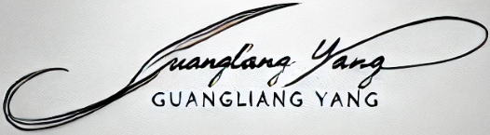

**Acknowledgment**

First and foremost, I extend my deepest gratitude to my wife for her unwavering support, boundless encouragement, and thoughtful care, which have been instrumental in enabling me to pursue and complete my Master’s degree at Auckland University of Technology (AUT), New Zealand.

I am immensely thankful to my primary supervisor, Dr. Wei Qi Yan, for his exceptional expertise, insightful guidance, and constant encouragement, which were integral to the success of this study. His mentorship has not only enhanced my understanding of the subject but also enriched my academic journey. I am equally grateful to my secondary supervisor, Minh Nguyen, and my third supervisor, Xue Jun Li, whose valuable advice and support played a significant role in shaping this research. Lastly, I wish to thank the administrators and faculty members at AUT for their continuous assistance and guidance throughout my studies.

GuangLiang Yang

Auckland, New Zealand

December 2024

# Chapter 1 Introduction

*This chapter is composed of five parts: The first part introduces the background and motivations, the second part includes the research question, followed by the contributions, objectives, and structure of this report.*

## Background and Motivation

With the rapid development of artificial intelligence, particularly large language models (LLMs), the capability of understanding and generating language has reached unprecedented levels. LLMs have gradually permeated various fields, from general-purpose chatbots to domain-specific intelligent tools, such as education, healthcare, and sports. In competitive sports, the efficient analysis of match data and its transformation into actionable tactical guidance has become a focal point for athletes and coaches (Solomon & Laye, 2024; Hegde et al., 2024; Fu et al., 2024; Xia et al., 2024).

In table tennis, a high-intensity and fast-paced sport, data analysis involves statistical metrics, complex rule interpretation, and strategic decision-making. However, existing technologies primarily focus on match video analysis and technical statistics, lacking real-time interactive and personalized guidance functionalities (Poolton, Masters, & Maxwell, 2006; Raab, Masters, & Maxwell, 2005). Effective leveraging of these technologies to provide intelligent, actionable solutions for match data analysis and training remains an open challenge.

Recent breakthroughs in computer vision (CV) and deep learning have revolutionized sports analytics. YOLO (You Only Look Once) models have proven highly effective in detecting small, fast-moving objects like table tennis balls, while multi-camera setups have facilitated precise 3D trajectory reconstruction (Jiang et al., 2022). These technologies have dramatically improved the accuracy of ball tracking, speed analysis, and serve legality detection. However, current solutions are often constrained to basic data analysis and fail to provide deeper semantic insights or actionable guidance for players and coaches.

The integration of Large Language Models (LLMs) with computer vision (CV) technologies presents a groundbreaking opportunity in sports analytics. LLMs, with their advanced natural language understanding and generation capabilities, can bridge the gap between raw data and actionable insights, transforming static data outputs into interactive and personalized coaching advice. By leveraging detailed data on ball trajectories, player movements, and hitting techniques, such systems empower athletes and coaches to identify strengths, address weaknesses, and adapt strategies to specific match scenarios. For example, players can receive tailored feedback to refine their techniques, improve footwork, or counter an opponent's play style. These integrated systems not only enhance training efficiency but also provide real-time decision-making support during matches.

Building on research in real-time table tennis match analysis using multi-camera 3D reconstruction and object detection, which focused on static data outputs, this study advances the field by introducing Chat Ping Pong Game (ChatPPG). ChatPPG is a novel framework that integrates CV and LLM technologies to process real-time data and generate natural language feedback. This system provides personalized tactical and training suggestions for table tennis athletes and coaches, addressing the need for deeper semantic insights and interactive applications. By pushing the boundaries of AI-driven sports analytics, this research establishes a new standard for how data-driven tools can support athletes and coaches in high-speed, high-precision sports.

## Research Questions

This study addresses critical challenges in table tennis analytics and aims to explore innovative solutions through the integration of computer vision (CV), deep learning, and large language models (LLMs). The primary research questions guiding this study are:

1. How can multi-camera systems enhance the precision of ball tracking and 3D trajectory reconstruction in table tennis?

This question seeks to evaluate the effectiveness of using synchronized multi-camera setups to overcome limitations such as occlusions and depth perception issues that hinder single-camera systems.

1. What are the key trajectory features and events (e.g., throw point, highest point, and hit point) that can be automatically identified to improve serve legality detection?

This question focuses on understanding the dynamics of the ball's motion and exploring how deep learning models, such as YOLO and Transformer, can detect critical trajectory points.

1. Can Large Language Models (LLMs) provide actionable insights and real-time feedback by interpreting raw data from computer vision models?

This question aims to determine how LLMs, fine-tuned with domain-specific data, can translate numerical and visual data into meaningful coaching advice, tactical suggestions, and rule compliance evaluation.

1. How can an integrated framework combining CV, deep learning, and LLMs support real-time decision-making during matches and training?

This question investigates the feasibility of creating an interactive system that not only analyzes data but also provides real-time feedback to athletes and coaches in high-speed, high-stakes scenarios.

By addressing these questions, this study aims to bridge the gap between advanced data analysis and practical applications in table tennis, ultimately transforming how athletes and coaches utilize technology to enhance performance and ensure fair play.

## Contributions

The This study presents several key contributions that advance the integration of computer vision, deep learning, and large language models (LLMs) in the context of table tennis analytics:

1. Efficient 3D Reconstruction for Dynamic Environments

A novel calibration method leveraging the inherent dimensions of the table tennis court was developed, enabling rapid 3D reconstruction of the playing environment during venue changes. This approach facilitates accurate tracking of player speed and activity range.

1. YOLO Optimization for Small Object Scenarios

YOLO was optimized specifically for small, fast-moving objects like table tennis balls, resulting in improved accuracy in 3D tracking and detection. This enhancement addresses challenges unique to high-speed sports analytics.

1. Precise Video Segmentation Using 3D Trajectories

A trajectory-based approach was implemented to achieve fine-grained video segmentation, enabling action segmentation for table tennis players. This allows detailed analysis of specific movements and sequences during gameplay.

1. Transformer-Based Trajectory Analysis for Key Turning Points

Transformer models were applied to 3D trajectory data to identify critical turning points, such as the throw point, highest point, and hit point. This analysis supports accurate serve legality assessments and data collection for foul detection.

1. Development of a Domain-Specific Q/A Dataset

A custom dataset was constructed to train LLMs, incorporating match statistics, training suggestions, and strategic advice tailored to table tennis. This dataset ensures domain relevance and enhances the model’s performance.

1. LoRA Fine-Tuning for Table Tennis Scenarios

LoRA fine-tuning was employed to optimize the LLM for understanding and generating outputs specific to table tennis. This validated the feasibility of combining LLMs with computer vision for real-time analysis.

1. Interactive Intelligent Assistant for Match Data

An innovative application was developed to transform traditional data analysis tools into an interactive intelligent assistant. This system improves the interpretability and usability of match data, providing actionable insights and real-time guidance for players and coaches.

## Objectives of This Report

This report aims to tackle key challenges in table tennis analytics by proposing a comprehensive framework that integrates computer vision (CV), deep learning, and large language models (LLMs). A central objective is to design and implement a robust multi-camera system capable of precise 3D trajectory reconstruction and tracking of table tennis balls and players, even in high-speed scenarios. Such a system is intended to overcome limitations like occlusions and depth perception challenges inherent in traditional single-camera setups.

Another goal is to explore the application of advanced deep learning models, such as YOLO and Transformers, to improve small object detection and analyze ball trajectories. Special attention is given to identifying critical turning points, such as the throw, highest, and hit points, and leveraging these insights for accurate serve legality assessments. In parallel, the study seeks to develop methods for trajectory-based video segmentation, enabling detailed analysis of player actions and technical movements throughout a match.

Finally, the report focuses on integrating LLMs fine-tuned with domain-specific datasets to interpret the outputs of CV models and provide actionable feedback. This includes transforming raw data into meaningful insights, such as tactical recommendations, training plans, and real-time serve compliance evaluations. By combining these components, the ultimate objective is to create an interactive and intelligent system that supports players, coaches, and referees by delivering real-time decision-making assistance and enhancing the usability of AI-driven tools in table tennis.

## Structure of This Report

The description of this report is as follows:

* Chapter 2: Related Work examines prior research in computer vision, deep learning, and large language models as applied to sports analytics. It highlights the limitations of existing methods and identifies the research gap this study aims to address.
* Chapter 3: Methodology details the experimental setup, including the multi-camera system, data collection processes, and calibration techniques for 3D trajectory reconstruction. This chapter also describes the optimization of YOLO and Transformer models, the construction of domain-specific datasets, and the fine-tuning of LLMs with LoRA.
* Chapter 4: Results present the outcomes of the proposed framework, including metrics for ball detection and tracking accuracy, key trajectory point identification, serve compliance evaluation, and real-time interaction capabilities. It includes both quantitative results and qualitative insights gained through practical application.
* Chapter 5: Discussion analyzes the implications of the findings, comparing them with prior research. It explores the strengths and limitations of the proposed approach and discusses potential improvements for future studies.
* Chapter 6: Conclusion summarizes the key contributions and achievements of the study, emphasizing its impact on table tennis analytics. It also outlines possible directions for extending this research to other fast-paced individual sports.

# Chapter 2 Related Work

*The focus of this report is on integrating CV, 3D tracking, and LLMs to create a real-time intelligent system for table tennis analysis, this chapter will introduce a plenty of traditional methods and the relevant knowledge of Multimodal and Multi-stream.*

## Introduction

In recent years, the application of CV, 3D tracking, LLMs, and multimodal & multi-stream methods has become crucial for advancing performance analysis and automation in sports (Schilling et al., 2024). These domains contribute to the development of real-time, precise systems capable of tracking ball movement, predicting trajectories, and providing actionable insights for players and coaches.

## Computer Vision

Table tennis has exceptionally technical requirements as a high-speed and precise sport. Especially in modern competitions, real-time tracking of the table tennis ball with GPU and accurate prediction of its trajectory and landing point has become the focus of state-of-the-art research topic. The ball has a fast speed, small size, light weight and complex trajectory. Therefore, achieving high-precision detection and trajectory tracking of the balls in real time has become a major challenge in computer vision (Zhou et al., 2024).

With the rapid development of deep learning, more and more research work is devoted to improve small object detection and track accuracy and efficiency (Yan, W. Q. 2023). YOLO (You Only Look Once) and DETR (Detection Transformer) are two representative models, each with distinct advantages and application scenarios. The YOLO series is renowned for its extremely fast detection speed and high accuracy. It is particularly suitable for applications with real-time requirements, such as autonomous driving, security surveillance, and sports analysis. In table tennis, the ball is small, fast, and follows a complex trajectory. YOLO models excel in quickly locating the ball and demonstrate superior performance in detecting fast-moving visual objects. YOLO models achieve visual object localization and classification in a single forward pass, and the lightweight structure enables it to run on devices with lower hardware requirements, which is highly valuable for real-time analysis in table tennis (Yan, W. Q. 2023).

In contrast, DETR (Zhao et al., 2024) is a transformer-based object detection model that captures global features through a self-attention mechanism. It is particularly suitable for complex scenes. DETR avoids traditional anchor-box mechanism, instead directly predicting bounding box positions and classes. While this approach excels in multiobject detection for large images, its detection speed is relatively slower. Although the improved RT-DETR surpasses YOLOv8 in speed, it does not exceed YOLO11. In table tennis, the longer inference time of DETR and lower sensitivity to small objects make it less ideal for high-speed applications, where YOLO generally performs better. Thus, YOLO is more suitable for detecting fast-moving small objects in table tennis, while DETR excels in detecting static or slow-moving objects in complex backgrounds.

TrackNet is a model specifically designed for sports scenarios. It is particularly effective in detecting and tracking fast-moving objects like table tennis balls (Huang et al., 2019). By combining detection and tracking in an end-to-end framework, TrackNet processes video frame sequences and leverages temporal information to predict object positions. This gives TrackNet a significant advantage in capturing the precise position of a fast-moving ball in each frame. However, as a specialized model, it heavily relies on specific training datasets and may not be suitable for more flexible and dynamic environments.

## 3D

In our research project, not only is the real-time detection of table tennis ball, but its trajectory also needs to be accurately tracked to improve the prediction of landing points of table tennis balls. However, the trajectory prediction of a table tennis ball is far from simple. Affected by gravity, air resistance, and the spin of the table tennis ball, its trajectory is not a plane parabola according to the Magnus effect but a smooth 3D curve (Liu et al., 2012). Therefore, we introduced stereo vision based on a binocular camera to obtain the 3D location of the table tennis ball. Based on these precise 3D coordinates, we track the movement of the table tennis ball in real time and accurately predict its landing point.

Multiple studies (Lin et al., 2020; Calandre et al., 2021) have showcased the forces affecting a table tennis ball during play. These primarily include gravity, drag force, and Magnus force due to spin, as shown in Equation (1).

$$\begin{aligned}m∙\frac{d^{2}\vec{r\left(t\right)}}{dt^{2}}=-m∙g∙\hat{k}- \frac{1}{2}∙C_{d}∙ρ∙A∙\left|\vec{υ}\left(t\right)\right|∙\vec{υ}\left(t\right)+S∙ρ ∙A∙\left(\vec{ω}×\vec{υ}\left(t\right)\right) (1)\end{aligned}$$

where $ρ$ represents the air density, which affects the magnitude of aerodynamic forces. ω is the angular velocity of the ball, which generates the Magnus effect due to the ball's spin. $\vec{υ}\left(t\right)$ is the velocity of the ball relative to the air, influencing both the drag and Magnus forces. The term $g$ stands for gravitational acceleration, which pulls the ball downwards, and mmm is the mass of the ball, affecting how much it accelerates in response to the forces. $A$ represents the cross-sectional area of the ball, playing a role in determining the size of the aerodynamic drag and Magnus forces. $C_{d}$ ​ is the drag coefficient, describing the ball's resistance to air movement based on its shape and surface properties. $S$ is a constant that scales the Magnus force, which is the force resulting from the ball's spin interacting with its velocity. In addition, $d$ refers to the distance or displacement over time, typically represented in the form of derivatives, such as $\frac{d^{2}\vec{r\left(t\right)}}{dt^{2}}$ ​, which is the acceleration or second derivative of the position vector $\vec{υ}\left(t\right)$. This measures how fast the ball's velocity changes over time. Lastly, $\hat{k}$ is a unit vector in the vertical direction, often pointing upwards or downwards depending on the coordinate system, representing the direction of gravitational force. Equation (1) shows the nonlinear dynamic system, with each force varying over time. Therefore, the trajectory of the ball is usually not confined to a curve within a single vertical plane.

As analyzed (Zhou et al., 2024), the assumption of ball moving within a plane is limited. The study utilized a single camera to detect the moment the ball hits the table. The ball contacts with the table is determined by comparing the sign changes in the y-axis coordinates of the ball center between the previous two frames and the current frame. Furthermore, the ball landing area was estimated by comparing the lower boundary of its bounding box with predefined table areas. However, the coordinates only consist of (x, y) coordinates, lacking depth (z-axis) data, which makes it impossible to determine the ball height or precise 3D position. The method only provides a rough estimate of the ball landing area by comparing overlapping regions without calculating the exact landing point. Moreover, the camera angle influences (x, y) coordinates and table area division in the image. The errors are magnified when the ball is far from the camera or at extreme angles. Thus, camera placement is critical, and table areas must be as prominent as possible in the video frame, which also limits the bounce height of the ball.

The method for calculating ball displacement (Zhou et al., 2024) also has significant limitations. By initializing the z-coordinate as a unified value for perspective transformation, 2D image coordinates are mapped to 3D space and the depth information along the z-axis is constant as assumed. This approach only accurately computes the movement in the x and y-plane and cannot capture variations in the z-axis. Although auxiliary cameras from the side were suggested to reduce errors from movement along the optical axis of the primary camera, all calculations are still based on 2D coordinates. This simplification leads to limitations in the results, where the calculated velocity only reflects movement in the image plane rather than the real-world velocity of the ball. As a result, this method may fail to accurately predict the trajectory of a flying ball, especially in scenarios which require high precision.

The calibration process for the camera has significant limitations, especially in acquiring extrinsic parameters (Zhou et al., 2024). A chessboard must be brought to the table for calibration, and any changes to the training venue or camera position necessitate recalibration. Using the table and net standard dimensions to calculate extrinsic parameters requires manual pixel location in images to make automatic calibration impossible. Klette (2014) introduced calibration principles, where intrinsic and extrinsic parameters are precisely calculated by minimizing reprojection errors using nonlinear optimization algorithms, such as Levenberg-Marquardt algorithm. The study also explained how epipolar geometry can be employed in stereo vision to determine 3D coordinates through triangulation by matching corresponding points in left and right images. Moreover, the “Third-Eye” technique utilizes images and geometric information from two known cameras (stereo cameras) to estimate the content of a hypothetical third-camera view.

## Large Language Models

The application of LLMs in sports has rapidly gained traction, demonstrating their potential to analyze complex data and provide actionable insights (Xia et al., 2024). In recent years, LLMs have been utilized in areas such as athlete psychology assessment, match data summarization and tactical optimization. For example, studies have explored using LLMs to interpret interview data and provide psychological insights for athletes, as well as to automatically generate post-match reports and tactical analyses. These models have also been leveraged in team sports like football and basketball to evaluate and optimize strategic setups (Schilling et al., 2024; Held et al., 2024; Liu et al., 2025; Hu et al., 2024). However, despite the success in these domains, the integration of LLMs into fast-paced individual sports such as table tennis remains underexplored. This gap underscores the need for innovative approaches to harness the capabilities of LLMs to provide real-time, actionable guidance for players and coaches.

In table tennis, Computer Vision (CV) has led to significant advancements in data collection and analysis, particularly for a sport characterized by its high speed and small object size. Multi-camera 3D reconstruction techniques have enabled precise tracking of athlete movements, generating heatmaps to evaluate court coverage and activity distribution (Zhou et al., 2024). Similarly, pose estimation tools like MediaPipe have been applied to analyze technical actions, offering insights into areas such as stroke mechanics and footwork (Xu et al., 2024). Furthermore, rule compliance detection systems utilizing object detection algorithms have shown promise in evaluating service legality by analyzing parameters such as toss height and hand positioning. Building on these developments, our prior studies laid a solid foundation for table tennis data analysis. The first study introduced a real-time system for analyzing player movements and actions, providing speed, action frequency, and court coverage data. The second study developed a framework for detecting service rule violations, offering precise feedback on foul types and their occurrences. While effective for statistical analysis, these studies lacked semantic interpretation and interactive guidance capabilities, which this research aims to address.

Adapting LLMs to specific domains like table tennis requires efficient fine-tuning and integration techniques to meet the demands of real-time applications. Traditional full-parameter fine-tuning, though effective, is resource-intensive and unsuitable for lightweight implementations. To address these challenges, LoRA has emerged as a practical solution, enabling the fine-tuning of LLMs by training only small, adaptable layers while keeping most parameters frozen. This approach significantly reduces computational overhead while retaining performance (Hu et al., 2021). Prompt engineering has proven to be a powerful tool for tailoring LLM outputs by designing input structures that guide the model to produce accurate and contextually relevant responses (Chen et al., 2024). In parallel, model quantization—reducing parameter precision to 8-bit or lower—has improved inference speed and reduced memory consumption, making LLMs more efficient for real-time scenarios (Dettmers et al., 2023; Xiao et al., 2023).

Function Calling, on the other hand, facilitates the seamless integration of LLMs with external APIs and pre-existing systems, enabling them to execute predefined functions and retrieve specific data dynamically. This capability significantly expands the practical applications of LLMs by allowing real-time interaction with complementary technologies (Qin et al., 2023). For example, in healthcare, function calling has been used to integrate LLMs with electronic medical record systems for automated diagnostics (Ahsan et al., 2024), while in autonomous systems, it has enabled real-time data exchange between LLMs and sensor-based control units (Ferrara et al., 2024). These techniques collectively enable LLMs to operate as the core of complex, multi-component frameworks, bridging the gap between standalone data processing and interactive, context-aware systems. In this study, prompt engineering and function calling were pivotal in integrating ChatPPG with prior CV models. Prompt engineering was used to structure interactions between the LLM and visual data outputs.

One of the greatest challenges in using LLMs is the lack of interpretability and transparency. LLMs often operate as black-box models, making understanding or explaining their decision-making processes difficult (Kim et al., 2024). Efforts to improve interpretability, such as attention mechanisms and visualizing model outputs, have offered insights into how LLMs process and analyze data. For example, Held et al. proposed a multimodal LLM framework, “X-VARS,” which combines visual-language models with precise visual feature inputs to enhance interpretability in football referee decision-making. This system explains decisions comparable to professional referees, providing transparency to the processes of the model (Held et al., 2024). In this study, ChatPPG significantly enhances the transparency and interpretability of the LLM by integrating precise data from CV modules as input. By incorporating structured CV outputs such as 3D trajectories and player performance metrics, ChatPPG allows for clearer explanations of its recommendations and decisions. This integration bridges the gap between opaque LLM outputs and the actionable insights demanded in table tennis coaching and competition scenarios.

## Multimodal & multi-stream

Multimodal approaches, such as those employed in ViLT, CLIP, and Blip2, are not directly applicable due to several domain-specific constraints and requirements. Multimodal models like ViLT, which integrates vision and language without convolution or region supervision (Kim, Son, & Kim, 2021), and CLIP, which leverages natural language supervision for transferable visual models (Radford et al., 2021), have revolutionized cross-modal tasks such as visual question answering and image-text retrieval. Similarly, Blip2, which combines frozen image encoders with large language models to enhance training efficiency, represents a significant advancement in multimodal learning (Li et al., 2023). However, these models often require substantial computational resources and involve complex modality fusion, making them less suitable for real-time sports analytics where sub-second latency is critical.

Similarly, multi-stream networks commonly used in action segmentation, which process different streams such as RGB, optical flow, and temporal data for action segmentation (e.g., TTNet) introduce further computational complexity that is impractical for live coaching systems. While such models excel in detecting and segmenting actions offline, their resource-heavy design conflicts with the lightweight and efficient processing needed for real-time sports analytics. ChatPPG is specifically designed for real-time performance, where rapid analysis and immediate feedback are critical. For example, multi-stream architectures like the Three-Stream 3D/1D CNN for fine-grained action classification and segmentation in table tennis (Martin et al., 2021) and action detection systems such as P2ANet designed for dense action detection in broadcasting videos (Bian et al., 2024) are highly accurate but computationally expensive, hindering their use in real-time scenarios. Moreover, modern techniques for temporal action segmentation, as analyzed by Ding et al. (2024), underscore the challenges of balancing computational demands with the granularity of action recognition, particularly in sports applications.

Additionally, ChatPPG focuses on leveraging specialized CV techniques, such as 3D ball trajectory tracking and pose estimation, paired with task-specific fine-tuning of LLMs for domain-specific Q/A accuracy. The integration of multimodal models in such a system would introduce unnecessary overhead, as the textual and visual data in ChatPPG are already processed independently and optimized for their respective tasks. This modular approach enhances both interpretability and efficiency, avoiding the complexity and resource intensity of fusing modalities while maintaining the system's transparency and actionable insights.

# Chapter 3 Methodology

*The main content of this chapter is to clearly articulate research methods, which satisfy the objectives of this report. The chapter mainly covers the details of research methodology for ChatPPG which will be clearly introduced with the confident and imaginative use of the feature description methods.*

## Introduction

ChatPPG integrates advanced CV, LLMs, and domain-specific tools to provide real-time analysis and guidance in table tennis. The workflow is designed to process match videos, extract actionable insights, and deliver them to coaches and players in an interactive format. Fig. 1 illustrates the overall architecture, which outlines the end-to-end process from data acquisition to professional analysis and user interaction.

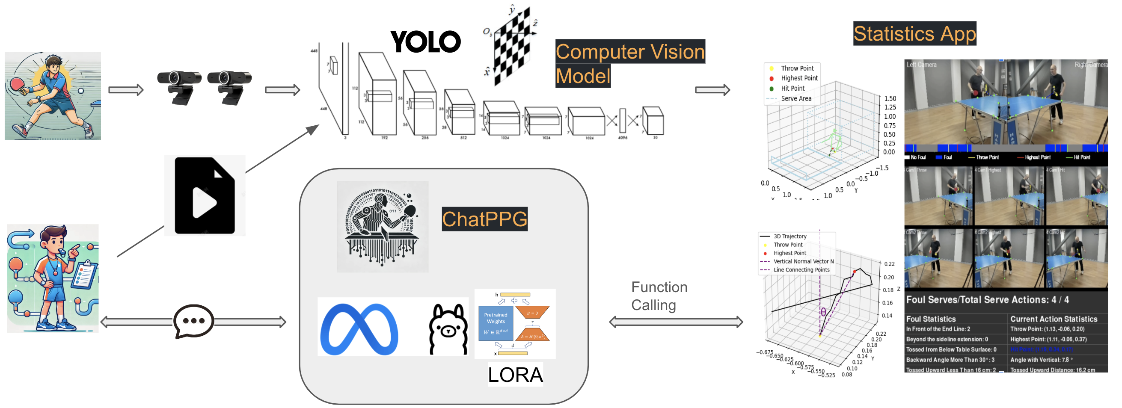

**Fig. 1** Workflow of ChatPPG for Real-Time Table Tennis Analysis and Guidance

(*This figure illustrates the end-to-end workflow of ChatPPG. The system begins with data acquisition from multiple cameras, followed by object detection, 3D world reconstruction, and 3D trajectory analysis using a computer vision module. These outputs feed into ChatPPG, an LLM fine-tuned with LoRA, which interacts with external tools via function calling. The system provides coaches and players with visualizations and actionable insights, enabling real-time analysis and guidance*)

The system begins with video recording using synchronized cameras, capable of capturing high-resolution footage at 120 frames per second. The recorded videos are processed using YOLO11 to identify and track key elements such as the ball and players. These detections serve as input to a multi-camera computer vision module, which reconstructs 3D trajectories of the ball and players' movements. This preprocessing step ensures that raw video data is transformed into structured inputs for subsequent analysis.

The CV module plays a critical role in analysing player behaviour and match dynamics. By leveraging ByteTrack (Zhang et al., 2022) tracking algorithms, it extracts key metrics such as player movement patterns, ball trajectories, and service legality. These outputs are integrated into the system's statistical engine to generate visualizations, such as movement heatmaps and trajectory plots, which provide quantitative insights into match performance. The CV module outputs form the basis for higher-level reasoning handled by ChatPPG.

At the core of the system lies ChatPPG, an LLM fine-tuned using LoRA for table tennis-specific tasks. Function calling ensures the LLM can invoke appropriate external tools for specific computations, such as analyzing player performance or detecting fouls. This approach enables ChatPPG to combine the reasoning capabilities of LLMs with the precision of CV tools, delivering accurate and task-specific outputs. For example, the system can analyze a player’s forehand speed or detect violations in service rules based solely on tool-generated results.

The final outputs are presented through an interactive interface, allowing coaches and players to engage directly with the system. Visualizations from the CV module, such as 3D trajectory graphs and heatmaps, are combined with textual guidance from ChatPPG to provide actionable insights. Whether identifying a player’s strengths, suggesting tactical adjustments, or highlighting areas for improvement, the system ensures that information is clear, relevant, and accessible.

## Experimental Setup

The experimental setup consists of three high-speed cameras, each connected via USB 3.0 to ensure minimal latency and capable of recording at 60 frames per second (fps). The vision system employed three cameras: Two Logitech Brio 4K cameras, each operating at 90fps, and one Razer Kiyo Pro Ultra camera at 60fps. The two Brio 4K cameras were utilized as the primary binocular stereo cameras for calculating the 3D coordinates of the table tennis ball. These cameras were strategically positioned around the table tennis table to capture the motion of the ball from multiple perspectives, as shown in Fig. 2. The primary cameras, labelled Camera 1 and Camera 2, were placed to the left and right of the table, focusing on the critical serve area. This placement enabled the capture of the trajectory of the ball from multiple angles and facilitated the calculation of 3D coordinates by using triangulation, which was essential for accurate trajectory analysis and foul detection. The verification camera labelled Camera 3, was mounted on the ceiling above the athlete’s head, providing a top-down view that complemented the side views. While this overhead camera was not directly involved in 3D reconstruction, it improved tracking reliability by offering an additional perspective, instrumental in cases where the ball was occluded in the side views.

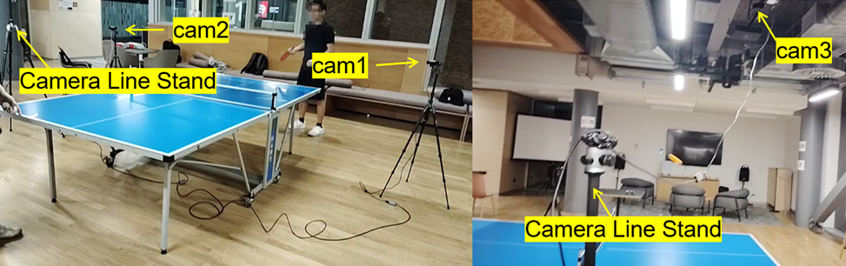

**Fig. 2** Multi-camera setup for table tennis serve foul detection

*(The cameras are positioned to capture different perspectives: Two cameras are placed at the left and right sides of the table, while a third camera is mounted overhead)*

This multi-camera setup was chosen over a single-camera configuration to address limitations related to depth perception and occlusions. In high-speed sports like table tennis, achieving a precise 3D perspective of the ball trajectory and detecting fouls requires synchronized multi-camera views. The combination of these cameras ensured robust tracking across various angles, minimizing tracking loss and allowing accurate monitoring of the ball’s position, even in complex scenarios. To ensure a controlled experimental environment, the setup was conducted indoors with uniform lighting to minimize external interferences such as shadows and lighting variations. The table was placed at the center of the setup, with clear space around it to allow unobstructed views from all cameras.

Processing and analysis were conducted on a Windows 11 system equipped with an NVIDIA GeForce RTX 4060 Laptop GPU to accelerate computationally intensive tasks such as real-time object detection and 3D reconstruction. Python and PyTorch served as the primary programming environment.

## LLMs Model

The training process employed LoRA fine-tuning and 8-bit quantization to optimize the LLM for real-time applications in table tennis.

### LoRA Fine-Tuning

LoRA significantly reduces computational and memory costs by introducing low-rank trainable matrices into the architecture while freezing the original pre-trained model parameters. This approach adapts large language models like LLama3 to specific tasks without requiring full re-training.

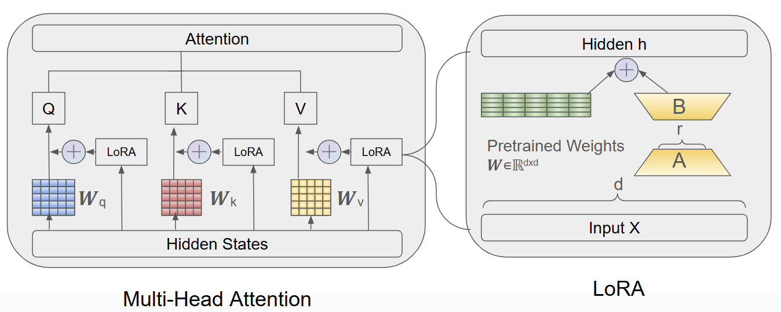

**Fig. 3** LoRA Integration in Transformer Architecture

*(The figure illustrates the integration of LoRA into the attention and feedforward layers of a transformer block. Low-rank matrices A and B are introduced into these layers, enabling efficient task-specific fine-tuning while freezing the original pre-trained weights $W_{0}$)*

Let $W_{0}∈R^{d×k}$ represent a pre-trained weight matrix in the model. LoRA modifies $W_{0}$ by adding a low-rank update ∆W:

$W=W_{0}+∆W, ∆W=\frac{α}{r}\left(A∙B\right)$ 2

where:

* $A∈R^{d×k}$ and $B∈R^{d×k}$ are trainable low-rank matrices.
* $r$ (LoRA Rank) is the rank of the low-rank decomposition, determining the dimensionality of $A$ and $B$. In this configuration, $r$ =8, striking a balance between model adaptation capacity and memory efficiency.
* $α$ (LoRA Alpha) is a scaling factor that amplifies the low-rank updates. Here, $α$ =16, ensuring that $∆W$ has sufficient impact on the final weight matrix.

The scaling factor $\frac{α}{r}$ ensures that the low-rank updates remain effective without destabilizing the optimization process. By only updating 𝐴 and 𝐵, the number of trainable parameters is drastically reduced from $d⋅k$ to 𝑟 ⋅ ( 𝑑 + 𝑘 ) , where 𝑟 ≪ min ( 𝑑 , 𝑘 ). As shown in Fig. 3, LoRA integrates into the transformer architecture by introducing 𝐴 and 𝐵 into attention projection layers and feedforward layers. This allows efficient task-specific adaptation while keeping the majority of the pre-trained model frozen.

In this paper, we employ LoRA updates to all trainable weight matrices in the attention and feedforward layers across all transformer blocks. This comprehensive targeting approach is illustrated in Fig. 3, where the low-rank matrices are seamlessly embedded into the relevant components of the transformer block. This configuration ensures robust adaptation to domain-specific tasks like real-time table tennis analytics.

### Quantization for Efficiency

The model was subjected to 8-bit quantization to enable real-time interaction, which significantly reduced memory usage and inference latency without compromising performance. Quantization involves reducing the precision of the model weights and activations from 32-bit floating-point (FP32) to 8-bit integers (INT8), thereby decreasing the computational overhead. This process allows the model to operate more efficiently, particularly on hardware with limited resources, while maintaining comparable accuracy.

### Prompt Design

Prompts were carefully designed to facilitate function calling and ensure that the LLM seamlessly interacts with CV Models for domain-specific computations. The design of these prompts enforces a structured workflow, where the LLM acts as an orchestrator that triggers appropriate CV Model functions and relays the results directly to the user without adding additional context or interpretation. For example, the following prompt structure enables function calling in Fig. 4:

You will receive a file from the user or politely request a picture for analysis. Based on the user's input, you will perform one of two tasks:

1. Analyze player performance (analy_table_tennis_performance in the provided tool).
2. Detect player foul (detect_player_foul in the provided tool).

For all user requests, you MUST use the provided tool to perform the computations. Your response must reflect ONLY the tool's output without adding personal interpretation.

**Fig. 4** Prompt Design for Function Calling in ChatPPG

*(This figure illustrates how the prompt guides the LLM to use external tools for analyzing player performance or detecting rule violations. Responses are strictly based on tool outputs, ensuring accuracy and reliability.)*

This prompt ensures that the LLM role strictly forwards user requests to the appropriate computational tool and returns the exact output.

## Computer Vision Model

### Calibration and 3D Reconstruction

Calibration involves two main components: intrinsic calibration, which determines the internal parameters of each camera, and extrinsic calibration, which aligns the cameras with a common coordinate system (Klette, 2014).

Intrinsic calibration was performed by using a chessboard pattern, a standard computer-vision technique for determining camera-specific parameters. The chessboard was placed within the view of each camera, and 100 images were captured. These images were then employed to calculate each camera’s intrinsic parameters, including focal length, optical center, and lens distortion coefficients.

After obtaining intrinsic parameters, extrinsic calibration was conducted to establish a standard 3D coordinate system across all cameras. This step involved identifying 16 fixed reference points around the table, as shown in Fig. 5, and measuring their precise coordinates. These points were chosen based on their visibility across multiple camera views, ensuring they could serve as reliable references for spatial alignment. Each reference point's position was marked in the video, and its coordinates in the 3D space were recorded. By associating the 2D coordinates of these points in each camera with the real-world 3D coordinates, the extrinsic parameters for each camera (rotation and translation vectors) were calculated.

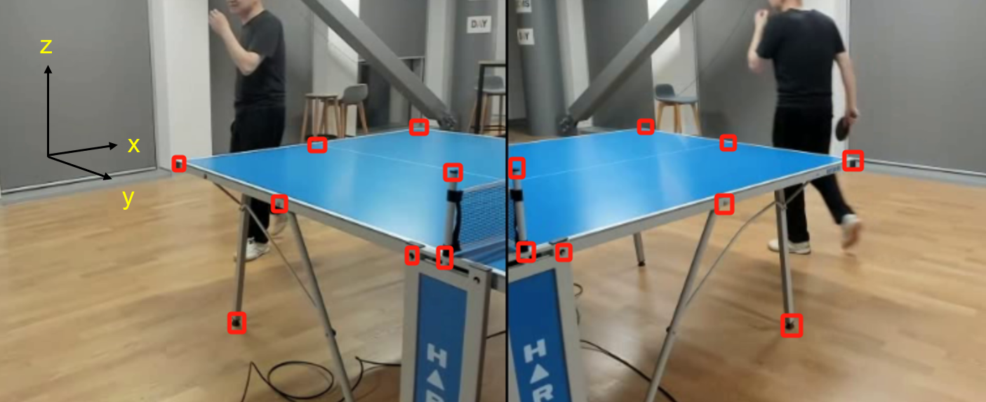

**Fig. 5** The calibration points are applied to align cameras with a coordinate system

*(The 16 fixed reference points are labelled with their 3D coordinates in the image, providing the foundation for accurate spatial calibration.)*

### Ball Detection

YOLO11 was selected for its high efficiency in detecting small, fast-moving objects, making it suitable for identifying a table tennis ball in each frame (Jiang et al., 2022). To optimize YOLO11 for the specific challenges of this project, several modifications were implemented to improve its accuracy in detecting small objects like the table tennis ball, which is often difficult to track due to its rapid motion and small size in the frame.

The standard YOLO11 architecture was adapted to enhance its sensitivity to small objects by removing the large object detection layers and incorporating a custom Resample Convolution (ResConv) layer, as shown in Fig. 6. The ResConv layer is designed to better handle small-scale features, allowing the model to focus on the fine details required for detecting small objects like the ball. Additionally, upsampling layers were modified to emphasize finer spatial resolution, which is crucial for capturing the movement of the ball accurately, even at high speeds.

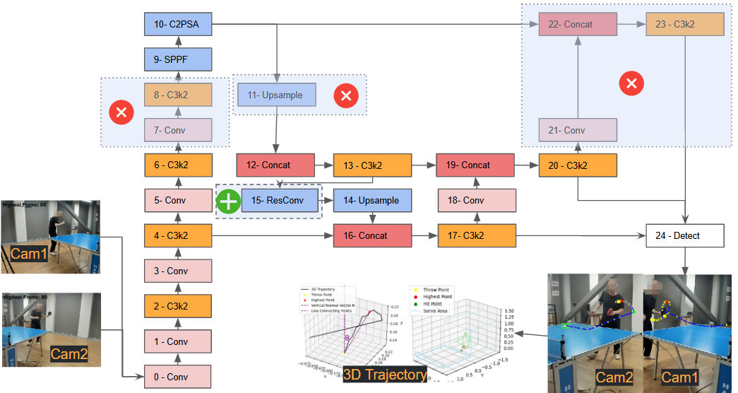

**Fig. 6** Modified YOLO11 architecture for small object detection

(The large object detection layer is removed, and a Custom ResConv layer is added to enhance detection performance for small, fast-moving objects like the table tennis ball.)

The ResConv layer is designed to enhance small object detection by preserving spatial details often lost during traditional downsampling. It divides the input tensor into smaller spatial components, retains localized features, and enriches the feature representation by concatenating these components along the channel dimension. A convolution operation then processes this enriched data to capture critical spatial relationships and improve the model's ability to detect small objects.

$Y=Conv(concat\left(X\left[…,∷2,∷2\right],X\left[…,1∷2,∷2\right],X\left[…,∷2,1∷2\right],X\left[…,1∷2,1∷2\right]\right))$ (3)

where $X$ is the input tensor with shape (B,C,H,W), B is the batch size, C is the number of channels, and H are W are the spatial dimensions. The input is sliced into four regions, capturing localized spatial information. These slices are concatenated along the channel dimension, resulting in a tensor $x^{'}$ of shape (B, 4C, H/2, W/2), with quadrupled channels and halved spatial resolution.

The concatenated tensor $x^{'}$ is passed through a 3×3 convolution, producing the output Y with shape (B, ouc, H/2, W/2), where ouc is the number of output channels. This process preserves critical details, ensuring robust small object detection while maintaining computational efficiency.

With this optimized YOLO11 model, the ball was detected simultaneously in frames from two cameras (Cam1 and Cam2) positioned to capture the serve area from distinct angles. By detecting the ball from two synchronized perspectives, the system can leverage data from multiple views, ensuring consistent tracking and reducing the likelihood of detection loss, even during rapid ball movements.

After detecting the ball in both camera feeds, the system applied calibration outcomes to reconstruct the ball position in 3D space. Using the intrinsic and extrinsic calibration parameters obtained earlier, the 2D coordinates of the ball from each camera were mapped to a standard 3D coordinate system. This triangulation process allowed for the precise calculation of the ball's position in 3D, enabling detailed trajectory analysis and accurate detection of key serve points, such as the throw, highest, and hit points.

### Ball Tracking

ByteTrack was employed to maintain the ball position across consecutive frames (Zhang et al., 2022). It is designed to associate every detection box, including low-confidence ones, improving its ability to handle objects with varying detection scores. This method has gained prominence for its robustness in tracking objects in challenging scenarios.

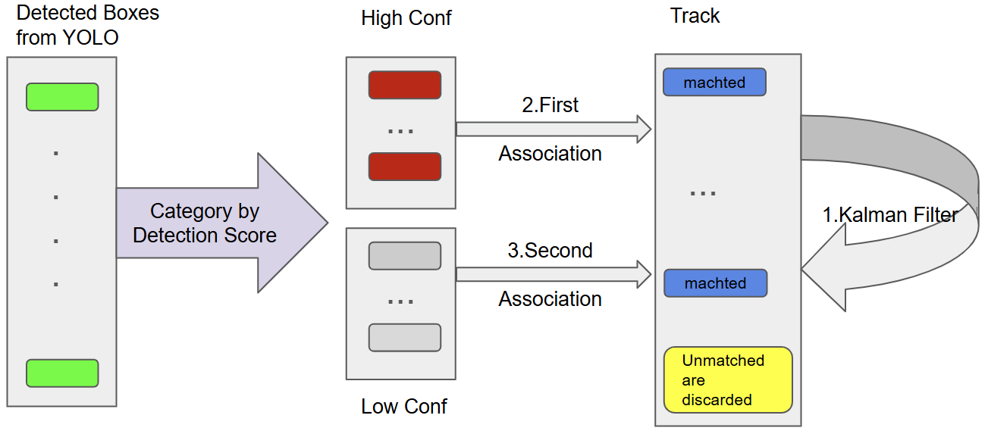

**Fig. 7** ByteTrack Framework for Table Tennis Ball Tracking starting from detection boxes output by YOLO

*(Detection boxes are categorized by confidence, with high-confidence boxes prioritized in the first association. Low-confidence detections are considered in a second association step, ensuring robust tracking. Kalman filter maintains smooth track predictions while unmatched tracks and detections are terminated or discarded.)*

As illustrated in Fig. 7, ByteTrack operates in two stages.. Firstly, the detection boxes from the YOLO detector are classified based on their confidence scores into high-confidence and low-confidence groups. High-confidence detections are matched to the existing tracks by using Intersection over Union (IoU), ensuring that the most reliable detections are prioritized. The unmatched low-confidence boxes are considered in a second round of association to address missed detections caused by occlusions, motion blur, or other factors. This two-stage matching process minimizes tracking loss and prevents objects from being prematurely discarded. Kalman filter is integrated to the ByteTrack framework, by predicting the positions of the existing tracks to maintain consistency and smoothness across frames. Tracks that remain unmatched for extended periods are terminated, while unmatched detections that fail the second association are discarded to optimize performance.

Fig. 7 provides an overview of the workflow of ByteTrack. The detection scores classify the detection boxes from YOLO into high-confidence and low-confidence groups. High-confidence detections undergo a first round of association with existing tracks, while low-confidence boxes are processed in a secondary matching step. Kalman filter algorithm predicts track positions and unmatched tracks or detections are discarded after multiple failed associations.

The background subtraction and optical flow methods (Yan, 2019) based on the OpenCV platform provide a simpler alternative for motion detection. However, they are susceptible to noise from lighting changes or background changes, which can cause track fragmentation. We will compare them with ByteTrack.

### Video Segmentation

The precise 3D trajectory of a table tennis ball, including its spatial coordinates and temporal sequence, is employed as the primary cue for segmenting video. The trajectory spans the entire serve action, from the ball's appearance to departure from the table. This approach significantly simplifies video segmentation in the context of table tennis serves, eliminating the need for multi-stream models.

Unlike recent methods that heavily rely on player pose estimation and multi-stream architectures integrating RGB data, optical flow, and player positioning (as seen in table tennis and tennis research) (Ding et al., 2024; Bian et al., 2024; Tran et al., 2024; Martin et al., 2021), the focus of this paper is exclusively on the ball 3D trajectory. The calibrated 3D coordinates of the ball provide sufficient information to isolate serve sequences without relying on additional data streams or complex model architectures.

The straightforward segmentation process relies on the spatial movement within the calibrated 3D space. A threshold Y>0.5, representing a spatial boundary in the serve area, is utilized to identify the serve sequence. This criterion isolates the serve action by focusing on the ball trajectory during its active involvement in the serve, effectively capturing the temporal and spatial characteristics of the sequence.

### Transformer Model for Key Point Detection

A Transformer model was applied to analyze the 3D trajectory of a table tennis serve and identify key turning points, such as the throw, highest, and hit points. This approach leverages the Transformer’s attention mechanism (Vaswani et al., 2017), which excels in capturing dependencies in sequential data, making it highly effective for recognizing patterns in the ball movement over time. By learning from labelled trajectories, the model can accurately predict critical points within the serve sequence, thereby enhancing the ability of this model to detect fouls based on serve dynamics.

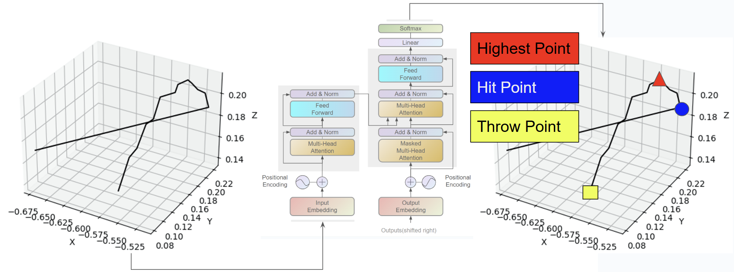

**Fig. 8** Trajectory visualization with annotated key points and Transformer-based turning point detection

*（The left panel shows the trajectory path, while the right panel highlights the annotated turning points (throw point, highest point, and hit point). The Transformer model outlines its components, such as multi-head attention, which enables it to process the trajectory data and extract key turning points）*

As shown in Fig. 8, the Transformer architecture is visualized alongside the 3D trajectory. The trajectory highlights the critical turning points: The throw point (marked as a yellow square), the highest point (marked as a red triangle), and the hit point (marked as a blue circle). The left panel depicts the 3D path of the ball, while the right panel overlays the annotated turning points on the trajectory. The Transformer framework on the right demonstrates how the positional encoding and multi-head attention layers enable the model to process sequential data and extract these key moments precisely.

Like Spatio-Temporal Transformer Networks (S2TNet) and the Trajectory Unified Transformer (Hu et al., 2024; Chen et al., 2021; Shi et al., 2023), Transformer-based models predict future positions in human motion or traffic data by identifying significant turning points. While these applications involve complex social interactions or environmental factors, the focus is on the ball’s motion alone, allowing the Transformer to concentrate on the trajectory patterns specific to the serve.

The Transformer model in this paper was trained on a dataset of labelled trajectories, where each serve sequence was annotated with the critical points of interest: The throw point (where the ball begins its upward toss), the highest point (the peak of the ball toss), and the hit point (where the player makes contact). These labels enabled the model to learn the specific patterns associated with each turning point in the serve. The attention mechanism of the Transformer allowed it to discern subtle changes in the ball movement over time, capturing dependencies that traditional models might overlook. This ability to track complex temporal dependencies made the Transformer model particularly well-suited for accurately identifying turning points in the trajectory.

### Rule-Based Foul Detection

A set of rule-based criteria is employed to determine whether a serve violates table tennis regulations. These criteria are designed to assess various aspects of the serve and provide objective data to assist referees in evaluating serve compliance (Nasution et al., 2024).

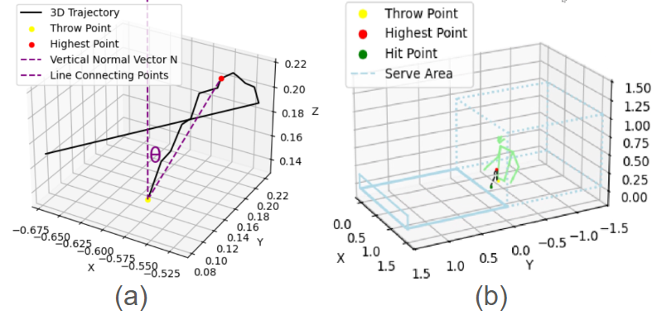

**Fig. 9** Rule-Based Foul Detection

*(a) 3D trajectory visualization with the throw point (yellow), the highest point (red), and the calculated vertical angle. The vertical normal vector and the line connecting the key points are included for clear representation. (b) Spatial analysis of the serving area, showing the trajectory of the ball relative to the permitted boundaries and confirming compliance with service area rules.*

**Minimum Drop Height:** To ensure that the serve meets the minimum height requirement, we monitor the ball trajectory to confirm it reaches a specified drop height. This criterion helps verify that the serve complies with the rules regarding the initial toss height.

**Vertical Angle at Throw:** This assesses the initial toss direction. To ensure that the toss remains near the vertical axis, we calculate the angle between the vector connecting the throw point and the highest point of the ball trajectory and the vertical reference vector (0,0,1). This angle is computed by using Equation(4).

$θ=\arccos\left(\frac{A_{x}⋅B_{x}+A_{y}⋅B_{y}+A_{z}⋅B_{z}}{\sqrt{A_{x}^{2}+A_{y}^{2}+A_{z}^{2}} ⋅\sqrt{B_{x}^{2}+B_{y}^{2}+B_{z}^{2}}}\right)×\frac{180}{π}$ (4)

where $A_{x}$, $A_{y}$, $A_{z}$ are the components of the vector $\vec{A}$, which connects the throw point to the highest point, and $B_{x}$, $B_{y}$, $B_{z}$ represent the components of the vertical reference vector $\vec{B}$ = (0, 0, 1). Equation (4) computes the angle in radians, which is then converted to degrees. If $θ$ exceeds 30°, the toss is flagged as a potential foul for excessive backward tilt. As illustrated in Fig. 9 (a), the system visualizes the ball’s 3D trajectory, indicating key points such as the throw point (yellow) and the highest point (red), along with the calculated vertical angle and the vertical reference vector. This visualization aids in understanding and validating the system’s assessment of the toss angle.

**Service Area Positioning:** The ball 3D coordinates are continuously tracked to ensure that the ball remains within the designated service area throughout the serve, as shown in Fig. 9 (b). This spatial analysis prevents serves from originating outside the legal area, ensuring compliance with spatial regulations.

## Dataset

### CV Customed training dataset

In table tennis, the complexity and dynamic nature of playing environment makes standardized datasets, such as TTNet and COCO, which are difficult to apply directly to our experimental scenario. While we leverage pretrained models to obtain initial parameters as a basis for model improvement, data collection and image processing must be optimized according to specific requirements. The custom training dataset in this paper incorporates geometric principles of binocular stereo vision and self-supervised learning, utilizing a multicamera system to generate incremental data and improve model detection performance.

We employed three cameras, as shown in Fig. 10, with two cameras (C1 and C2) capturing at 60 fps and the third camera (C3) at 30 fps. Due to the lower frame rate of C3, the images of the table tennis ball captured by this camera are more prone to blurry, contributing to the dataset diversity by providing various representations of the ball captured by using a low-speed camera. Data augmentation, such as variations in the ball size, rotation angle, and color, further enhanced the model generalization capabilities. While annotating the position of the table tennis ball, we primarily recorded its x- and y-coordinate in the image. Given the high-speed movement of the ball, blurry or trailing may occur in the images. For example, as shown in Fig. 10, the ball moves from right to left and leaves a motion trail, with the red circle indicating the marked coordinate. In such cases, we ensured the accuracy of the coordinates by marking the most recent position of the ball, providing a stable and reliable data input.

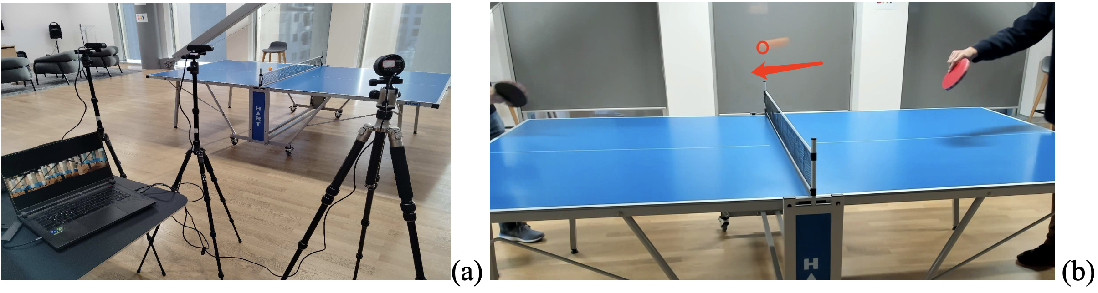

**Fig. 10** Data Collection: Multi-Camera Ping Pong Ball Capture with Motion Blur Annotation

*(a) Multicamera setup for capturing ping-pong balls (b)Annotated the balls with motion blur and trailing effect.*

In the context of data augmentation for table tennis, we employed several common image enhancement techniques aimed at improving the robustness of the object detection model, particularly for detecting and tracking fast-moving small objects like a table tennis ball.

As shown in Fig. 11, scaling was applied by enlarging or shrinking the images, allowing the model to handle objects at different distances. This is crucial in table tennis matches, where players are positioned at varying distances from the ball. Additionally, rotation was used to randomly rotate images, enabling the model to recognize the trajectory and spin from different angles of balls, which improved its adaptability to changes in ball orientation.

Translation involved randomly shifting the image horizontally, simulating the ball movement across the playing field, and helping the model better respond to the rapid motion of the ball. Brightness adjustment and color jittering were employed to maintain detection performance under varying lighting conditions and color changes, addressing the complex lighting environments often in table tennis venues.

Lastly, Gaussian blurring simulated the effects of camera blur or motion blur due to fast movement, which enhanced the model’s ability to detect the fast-moving ball even when image quality is degraded.

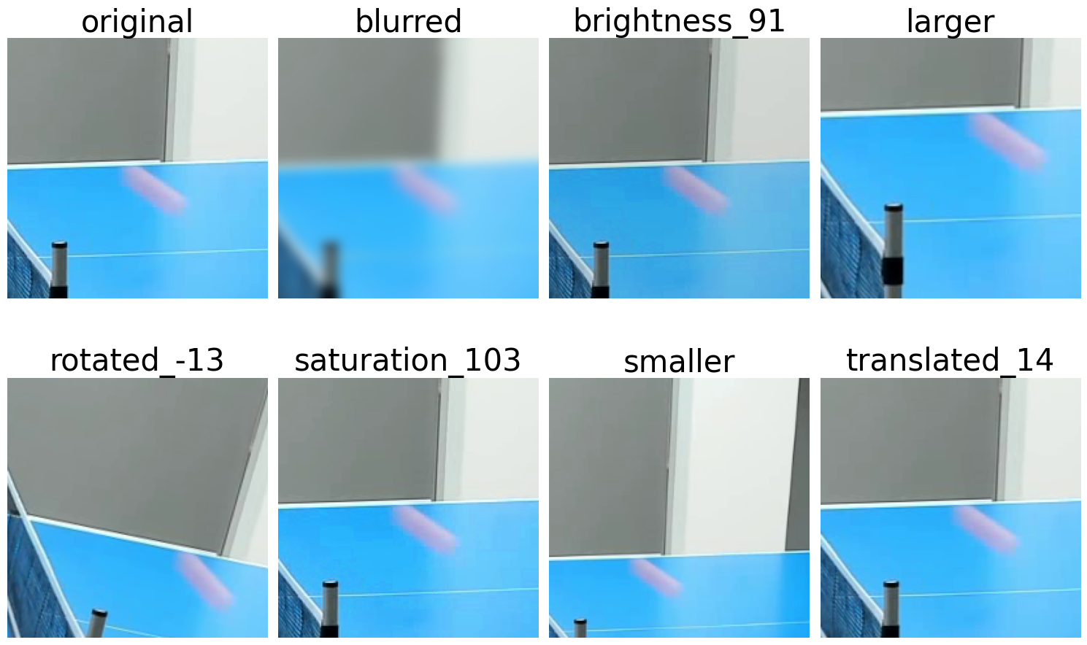

**Fig. 11** Data augmentation techniques applied to ping-pong balls detection.

Through this iterative process, the model progressively improves its detection accuracy across all cameras and maintains high precision even in complex game environments if camera frame rates are inconsistent. The combination of a custom dataset based on binocular stereo vision and self-supervised learning not only captures precise motion information of the table tennis ball but also provides robust training data through diverse image augmentation and pseudo-label strategies which ensures the broad applicability of the model in various scenarios.

### CV 3D Data Collection and Synchronization

A setup for video recording and frame alignment was implemented to capture and synchronize the fast-paced movements involved in a serve of table tennis. This process involved recording synchronized video feeds from multiple cameras and aligning frames across these feeds to enable precise 3D reconstruction of the ball trajectory (Poliakov et al., 2010).

Open Broadcaster Software (OBS) is used to manage the multi-camera setup and ensure frame synchronization across all video feeds (*Obsproject/Obs-Studio*, 2013/2024). By recording one composite video that includes views from all three cameras in designated sub-areas, OBS allowed for temporal alignment across all views (Fig. 12). This composite video was later split into individual feeds for each camera, preserving synchronization.

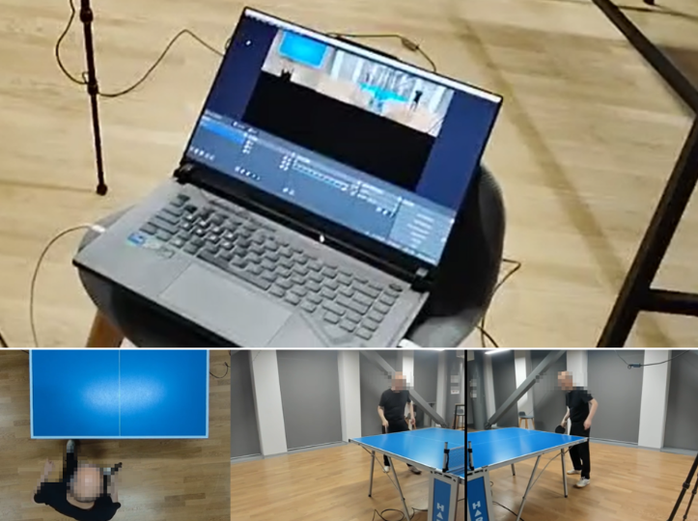

**Fig. 12** Frame alignment video recorded by OBS

*（The video layout shows the overhead view from the ceiling-mounted camera (left) and side views from the left and right cameras (right), allowing synchronized data capture across all views）*

After recording, the composite video was split into individual video feeds for each camera while preserving the frame-by-frame synchronization established by OBS. This splitting process ensured that every frame from each camera was perfectly aligned in time. To confirm frame alignment, a visual inspection was performed across the individual video feeds. The key points in the serve sequence, such as the ball toss and hit moments, were compared across all views to ensure that these actions occurred simultaneously in each camera. This alignment is critical for accurate 3D trajectory reconstruction; without precise alignment, any temporal mismatch between frames could lead to inaccuracies in calculating the 3D coordinates of the ball.

### LLMs training dataset

To adapt ChatPPG for table tennis, a domain-specific Q&A dataset was created by integrating data from prior studies, expert-curated training, and tactical suggestions. This dataset enabled ChatPPG to perform well in task-specific queries and significantly enhanced the transparency and interpretability of the system. By pairing structured input prompts with detailed explanatory outputs, the dataset allowed users to trace the reasoning behind the model recommendations, bridging the gap between raw data and actionable insights.

The dataset was built on two main sources. The first source included match statistics from previous studies, such as player speed, movement heatmaps, and action frequencies. These metrics formed the basis for understanding player behaviour and designing targeted interventions. Data on rule violations, including timestamps and violation types, also provided a foundation for corrective suggestions and compliance strategies. These structured outputs addressed user queries and revealed the underlying logic, making ChatPPG decision-making more interpretable.

Another key dataset component involved expert-curated training and tactical guides tailored to specific player profiles and skill levels. For instance, the dataset included entries on improving footwork speed, refining backhand techniques, and correcting frequent service violations. Each entry paired detailed input descriptions with step-by-step outputs, ensuring a clear relationship between data inputs and recommendations. This design enabled ChatPPG to generate actionable advice while offering transparency in how decisions were derived.

The dataset was carefully structured to include semantically rich and practically useful examples. For instance, a typical dataset entry might describe a player’s average speed and technical deficiencies, followed by an output that categorizes the player’s skill level and provides an improvement plan.

{

"instruction": "Determine the player's skill level based on performance metrics. Max = 0.02 km/h, Average = 0.01 km/h\n - Overall: Max = 0.06 km/h, Average = 0.03 km/h\n ...",

"input": "",

"output": "The player's skill level is categorized as Beginner, and playing style is identified as a Backhand-Dominant Attacker with limited technical variety. This conclusion is based on the following detailed analysis and theoretical underpinnings..."

},{

"instruction": " For a Beginner player with a Backhand-Dominant Attacker style and limited technical variety, provide a training and improvement plan.",

"input": "",

"output": " ### Professional Table Tennis Training and Improvement Plan:\n\n#### 1. Objectives:\n1. Enhance the diversity and stability of backhand techniques.\n2. Strengthen forehand skills to achieve a balanced attack and defense.\n3. Improve footwork and court coverage to handle higher-intensity matches.\n\n#### 2. Training Content:\n\n**1. Backhand Technique Improvement:**\n - **Backhand Power Training:**\n - Use multi-ball drills..."

},{

"instruction": " For an Advanced Backhand-Dominant Attacker player, provide strategies for competition scenarios. ",

"input": "",

"output": " "### Competition Strategies for an Advanced Backhand-Dominant Attacker:\n\n#### 1. Strengths to Leverage:\n1. **Backhand Dominance**:\n - Use quick and aggressive backhand topspin strokes to control the rally, especially in mid-table exchanges.\n - Take advantage..."

}…

**Fig. 13** Examples of Training Prompts and Outputs in ChatPPG Dataset

*(This figure presents structured dataset entries that enhance ChatPPG’s interpretability. The prompts describe specific player scenarios, while the outputs provide detailed and transparent recommendations, enabling users to understand the reasoning of the system.)*

To illustrate this, Fig. 13 showcases sample entries from the dataset, including prompts designed to determine a player’s skill level, craft a beginner’s training plan, and offer competition strategies for advanced players. These examples demonstrate ChatPPG ability to align its recommendations with specific player profiles and scenarios while maintaining transparency. By combining detailed CV data with domain expertise, the dataset ensures that ChatPPG delivers accurate and interpretable outputs, addressing the black-box nature typically associated with LLMs.

# Chapter 4 Results

*The main content of this chapter is to collect video data and demonstrate the experimental results. In the end, in this chapter, we also discuss the limitations of this project.*

## Computer Vision

This section provides a detailed analysis of the results produced by the CV models we trained. All training results refer to the model being trained based on our dataset for 300 epochs, with a batch size 16.

### Ball Detection

The performance was evaluated by comparing it with two benchmark models: YOLOv8 and YOLO11m. The evaluation focused on precision, recall, mAP@50, mAP@50:95, and training time. As shown in Table 1, our model achieved the highest detection accuracy across all metrics, demonstrating its superiority in handling the fast-moving, small-sized table tennis ball while maintaining competitive training efficiency. Specifically, our model achieved a precision 87.52%, a recall 83.37%, a mAP@50 86.87%, and a mAP@50:95 39.84%, outperforming both YOLOv8 and YOLO11m. The training time of our model was 4 hours and 33 minutes, slightly longer than YOLOv8 but shorter than YOLO11m, reflecting a balance between accuracy and efficiency.

Table 4.1 Performance values of YOLOv8, YOLO11m and this work

|  |  |  |  |  |  |  |
| --- | --- | --- | --- | --- | --- | --- |
|  | Precision |  | Recall | mAP50 | mAP50-95 | Training Time |
| YOLOv8 | 84.92% |  | 75.40% | 81.30% | 36.30% | 3hrs24mins |
| YOLO11m | 81.25% |  | 81.25% | 84.12% | 38.12% | 4hrs59mins |
| This work | 87.52% |  | 83.37% | 86.87% | 39.84% | 4hrs33mins |

The progression of these metrics over 300 training epochs is illustrated in Fig. 14, which provides a detailed comparison of the models. The precision plot shows that our model maintained consistently higher precision throughout the training process, indicating its ability to minimize false positives in detecting table tennis balls. Similarly, the recall plot demonstrates the capability of our model to detect a more significant proportion of true positives compared to the other models. In the mAP@50 plot, our model exhibits superior accuracy with less fluctuation, highlighting its robustness in detecting objects with an IoU threshold of 0.5. Our model shows steady improvement for the stricter mAP@50:95 metric, surpassing the performance of YOLOv8 and YOLO11m and confirming its reliability across a range of IoU thresholds.

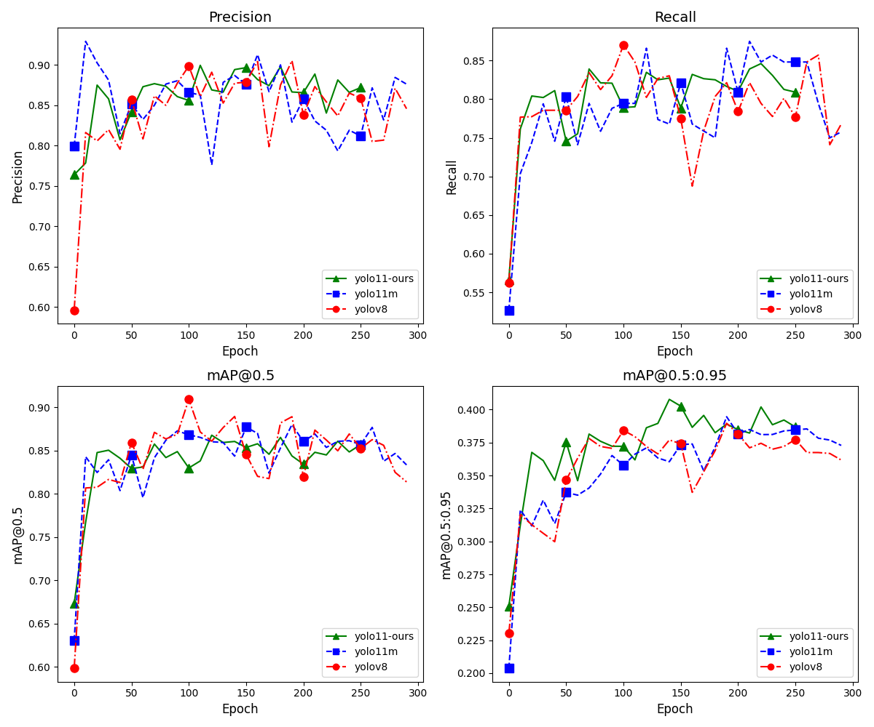

**Fig. 14** Performance metrics over training epochs for YOLOv8, YOLO11m, and our model.

*(Our model outperforms YOLOv8 and YOLO11m across all metrics, demonstrating its robustness and accuracy in table tennis ball detection.)*

Table 4.1 comparative analysis reveals that YOLOv8 benefits from a shorter training time but sacrifices detection accuracy, particularly in recall and mAP metrics. YOLO11m, on the other hand, achieves improved recall and mAP but at the expense of a longer training time. In contrast, our model achieves an optimal balance, delivering superior detection performance while maintaining reasonable training time. The enhanced results of our model can be attributed to its optimized detection layers and robust association mechanisms, which are particularly effective in tracking small, fast-moving objects like table tennis balls.

### Ball Tracking

The effectiveness of ball tracking methods in high-speed table tennis scenarios was evaluated by using two approaches: OpenCV background subtraction with optical flow and Byte-Track. Fig. 15 illustrates each method's performance and provides a side-by-side comparison of their tracking capabilities. The left panel demonstrates the results of background subtraction with optical flow, while the right panel highlights the superior performance of Byte-Track.

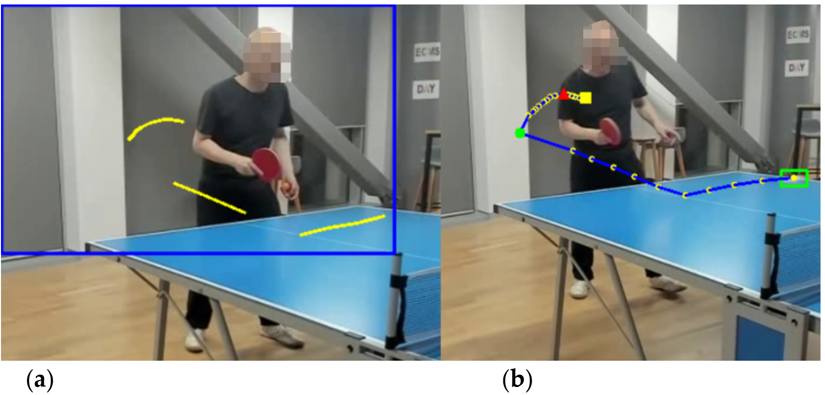

**Fig. 15** Comparison of Ball Tracking Methods

*(a) The OpenCV background subtraction and optical flow method result in fragmented and inconsistent ball trajectories due to background noise, rapid motion, and interference from moving players.*

*(b) The Byte-Track method delivers smoother and continuous ball trajectories, robustly handles complex motion, and maintains tracking consistency.*

Background subtraction and optical flow, implemented by using OpenCV, is relatively straightforward for detecting moving objects in a static or semi-static environment. This method isolates areas of motion by identifying changes between consecutive frames, allowing for the detection of objects like a table tennis ball. In this paper, the ball's movement is effectively captured against a stable background, as shown in the left panel of Fig. 15. However, this approach exhibited a few limitations. It was susceptible to background noise, such as shadows and reflections, which often led to fragmented detection results.

Additionally, moving players in the background introduced significant interference, making it challenging to distinguish between the ball and player movements. This interference frequently disrupted the tracking process, causing the trajectory to break or become inconsistent. Combined with the rapid and complex motion of the ball during a serve, these issues severely impacted the continuity of the tracking, hindering precise trajectory analysis.

In contrast, Byte-Track demonstrated superior performance by providing smoother and more continuous ball tracking, as depicted in the right side of Fig. 15. Byte-Track employs an advanced tracking mechanism that associates detected objects across frames using object size, movement consistency, and positional prediction features. This robust framework ensures track continuity, even during rapid directional changes or complex motion patterns. Unlike background subtraction, Byte-Track effectively handles the high-speed dynamics of table tennis serve, maintaining a stable and uninterrupted trajectory. Moreover, Byte-Track’s ability to focus on the ball as the primary object of interest mitigates the impact of background player movement, ensuring reliable tracking.

### Video Segmentation Results

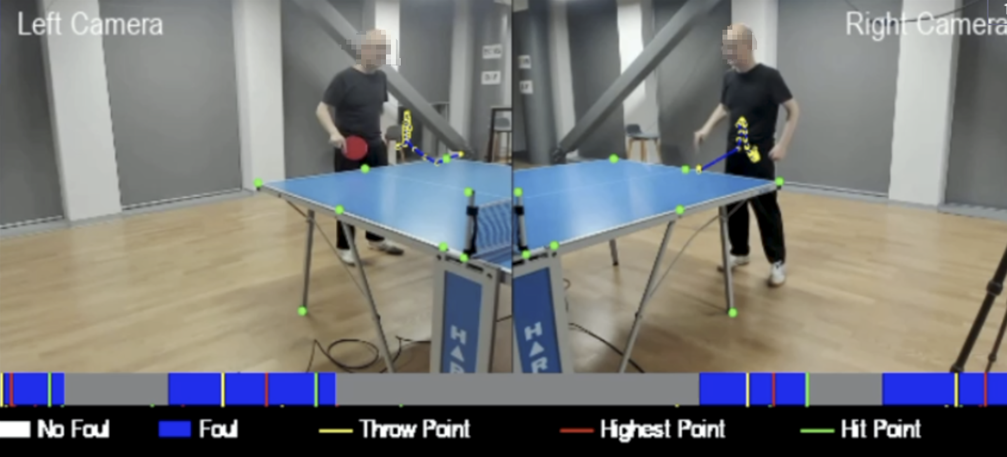

**Fig. 16** Key trajectory points and serve events visualized with synchronized camera views and segmented timeline for foul detection

*Video Segmentation Results: (Top) Synchronized left and right camera views showing key trajectory points during a table tennis serve. The throw point (yellow), highest point (red), and hit point (green) are marked to track the ball’s trajectory. (Bottom) Segmented timeline showing frame classification as "No Foul" (gray) and "Foul" (blue), with transitions aligned to the serve events.*

The video segmentation results demonstrate the effectiveness of the proposed system in identifying key events during table tennis serves and distinguishing between fouls and compliant serves. The segmentation process involves analyzing the ball 3D trajectory and detecting critical points, such as the throw point, the highest point, and the hit point, as shown in Fig. 16. Additionally, the frames are classified as either "No Foul" or "Foul," providing a detailed visual representation of the serve sequence.

In Fig. 16, the left and right camera views are synchronized to comprehensively analyze the serve. The key trajectory points are highlighted, with the yellow marker representing the throw point, the red marker indicating the highest point, and the green marker showing the hit point. This multi-camera approach ensures that all relevant motion events are accurately captured and analyzed. The segmented timeline clearly visualizes the classification results. Blue segments indicate fouls, while gray segments represent no-foul frames. The system can seamlessly identify transitions between compliant and non-compliant actions.

The robust identification of critical trajectory points further validates the segmentation, ensuring that serve sequences are broken down into precise segments. By leveraging the ball trajectory and synchronized video data, the system achieves reliable segmentation in scenarios with rapid motion or occlusions. This segmentation capability is essential for applications like foul detection and performance analysis, where detailed frame-level analysis is required.

### Transformer Model for Key Point Detection

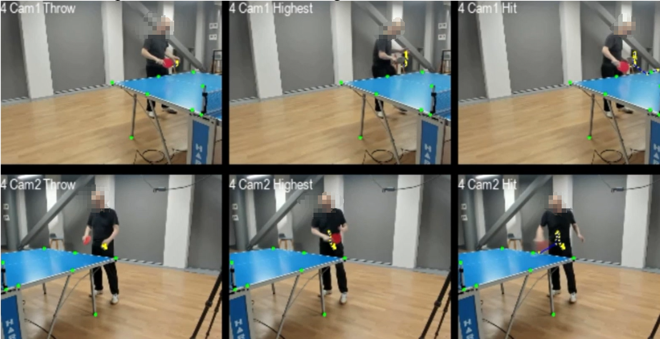

**Fig. 17** Multi-Camera Frames of Turning Points

*（Frames from Cam1 and Cam2 correspond to the throw point (yellow), highest point (red), and hit point (green), as detected by the Transformer model. The high F1 score (93) validates the accuracy of these turning points. ）*

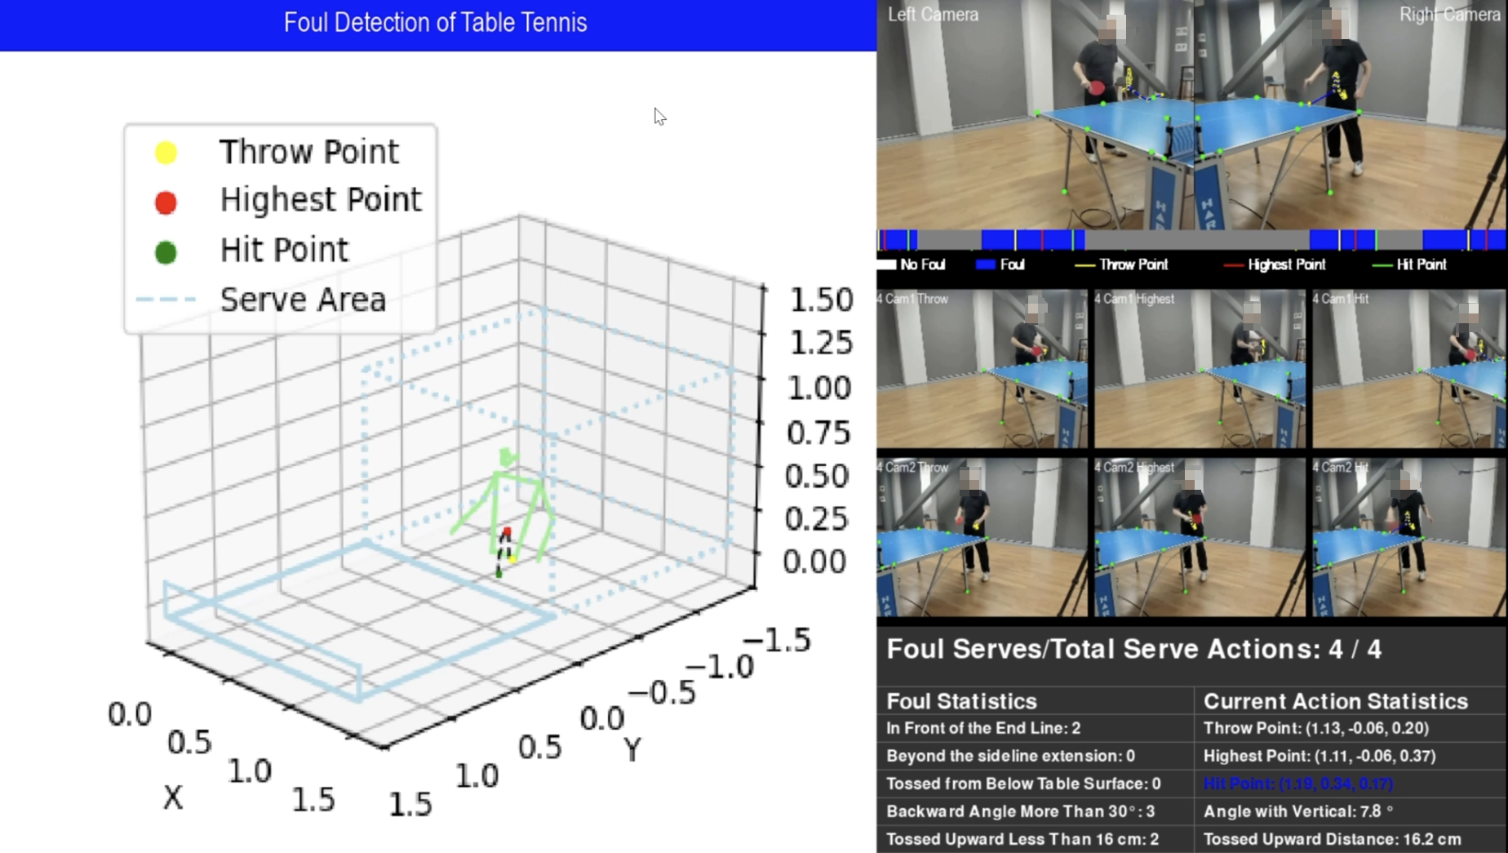

**Fig. 18** 3D Trajectory and Serve Statistics

*（The central 3D trajectory plot highlights the ball motion and key turning points aligned with the spatial limits of the serving area (dotted boundary box). The right side provides serve statistics, showing the timeline of compliant and non-compliant frames, foul counts, and detailed metrics for the current serve, including tossed upward distance and the angle with the vertical axis. ）*

The results, as shown in Fig. 17 and Fig. 18, demonstrate the effectiveness of the Transformer model in identifying key turning points during table tennis serves through synchronized multi-camera views, 3D trajectory analysis, and detailed serve statistics.

After the Transformer model calculated the turning points of the 3D trajectory, the corresponding frames were retrieved from two cameras (Cam1 and Cam2) based on the frame indices of the throw point, highest point, and hit point. These frames are displayed Fig. 17, showing synchronized views for the detected turning points. Our verification of these turning points yielded an F1 score 93, confirming the accuracy of the predictions and its reliability in detecting key moments during the serve.

Fig. 18 provides a comprehensive analysis of turning points within the 3D trajectory and foul detection context. The central 3D trajectory plot visually illustrates the ball motion, with key turning points (throw, highest, and hit points) highlighted. The plot also shows the spatial alignment with the serve area boundary, depicted as a dotted box. This boundary represents the permitted serve area, allowing the system to validate compliance with spatial rules. For example, the throw and hit points fall within the boundary, ensuring the serve adheres to spatial constraints.

The results of the experiment, as shown in Fig. 18, summarize all serve statistics during the athlete’s training session. The timeline clearly shows transitions between compliant frames (No Foul) and non-compliant frames (Foul), visually representing rule compliance. Multiple fouls were detected during the training session, along with the number of times each foul triggered its respective rule. The current serve action is also analyzed in detail, showing the 3D trajectory, the 3D coordinates of the three key turning points, the tossed upward distance, and the angle with the vertical axis.

## LLMs

### LoRA Fine-Tuning Results

The LoRA fine-tuning process significantly improved LLM adaptation to the specific requirements of the table tennis domain. The model exhibited rapid convergence during training, with the validation loss stabilizing after the eighth epoch. The fine-tuned model achieved 92.3% accuracy on the Q/A test set, significantly improving over the baseline model's accuracy of 83.7% . These results validate the effectiveness of LoRA in optimizing the model for domain-specific tasks with minimal computational overhead.

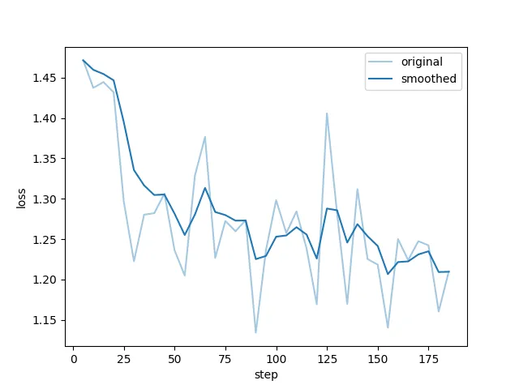

**Fig. 19** LoRA Fine-Tuning Training Loss Curve

*(This figure illustrates the training loss curve for LoRA fine-tuning. The "original" curve represents raw loss values across training steps, while the "smoothed" curve shows the averaged trend. The steady decline in loss highlights the model's rapid convergence and stabilization during fine-tuning.)*

As shown in Fig. 19, the training loss curve highlights the learning dynamics throughout the fine-tuning process. The "original" loss curve shows fluctuations corresponding to mini-batch updates, while the "smoothed" curve provides a clearer trend, demonstrating a steady reduction in loss over 186 epochs. The rapid decline during the early stages of training reflects efficient adaptation, while the plateauing behaviour in later epochs indicates stabilization and convergence.

### Real-Time Performance

In real-time scenarios, the quantized ChatPPG model demonstrated exceptional efficiency. By employing 8-bit quantization, the model reduced both memory requirements and inference latency, achieving an average response time of just 45 milliseconds per query. The system sustained throughput of 20 queries per second, representing a 2.7× improvement over the unquantized model. Furthermore, the end-to-end latency, which included CV data processing, inference, and feedback generation, consistently remained below one second. This performance underscores the suitability of ChatPPG for real-time applications, ensuring that actionable guidance can be delivered promptly during matches and training sessions.

### Practical Application Results

ChatPPG demonstrated its ability to provide actionable guidance and tactical recommendations tailored to specific scenarios when applied to real-world match simulations. By leveraging its integration with CV models, the system effectively analyzed uploaded match videos and engaged in interactive discussions with users, offering targeted insights and solutions. Fig. 20 illustrates an example of such interaction, showcasing a conversation between ChatPPG and the user based on analyzed video data.

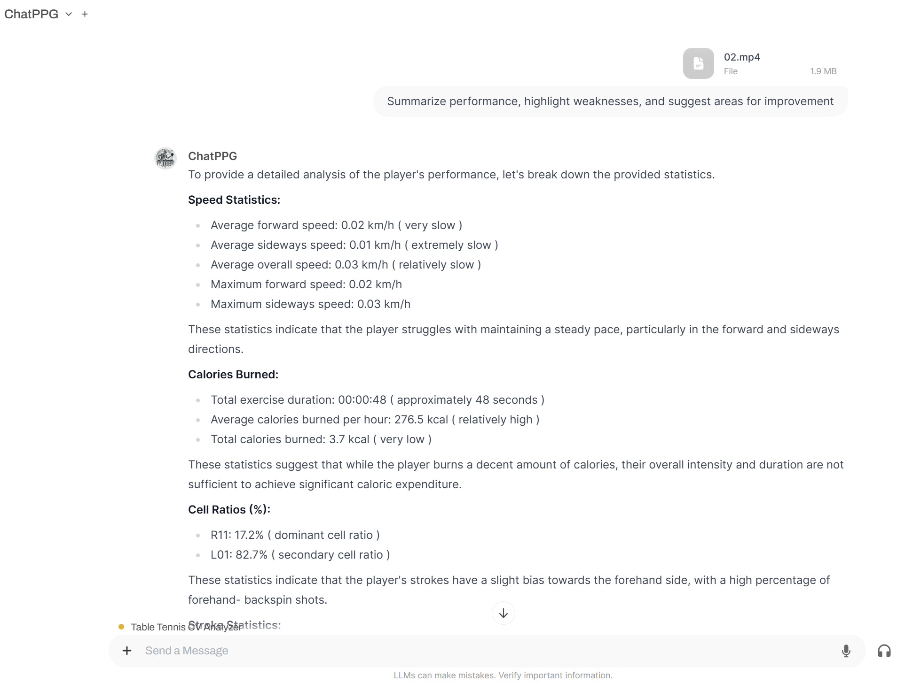

**Fig. 20** ChatPPG Interactive Conversation with User for Match Analysis

*(This figure showcases a real example of ChatPPG analyzing user-uploaded video data. The system summarizes key performance metrics, identifies areas for improvement, and provides actionable recommendations. Users can interact with ChatPPG by asking follow-up questions or evaluating the quality of its responses.)*

For instance, when queried about inconsistent forehand speed during rallies, the system recommended targeted drills, including wrist stability exercises and timing practice, to enhance execution consistency. Similarly, when analyzing frequent service fouls, ChatPPG identified potential issues, such as insufficient toss height and improper hand positioning, and proposed corrective measures to improve compliance with the rules.

Beyond handling individual queries, ChatPPG also demonstrated its ability to generate comprehensive training plans tailored to players’ profiles. The system provided

recommendations for speed-focused players to improve balance and endurance, while defensive players received guidance on refining counter-looping techniques and enhancing footwork drills. The system's tactical insights, such as optimizing shot placement and defensive positioning, further underscored its ability to support coaches in strategy refinement.

Fig. 20 illustrates a ChatPPG conversation where the user uploaded a video for performance analysis. The system utilized its CV models to extract relevant metrics, such as player speed, covered area, and calorie consumption and provided a detailed performance summary. ChatPPG also highlighted weaknesses, such as slow forward movement, and suggested improvements, including targeted training exercises. At the end of the interaction, users could evaluate the quality of ChatPPG responses, ensuring a feedback loop for continuous improvement.

### Interpretability and Transparency

One of ChatPPG's most notable strengths is its ability to deliver clear and interpretable responses, effectively bridging the gap between complex computational outputs and actionable insights. This is especially important in table tennis, where coaches and players rely on precise data to inform training and competition strategies. As illustrated in Fig. 21, ChatPPG evaluates a player's skill level based on structured metrics, transparently explaining each step in its decision-making process.

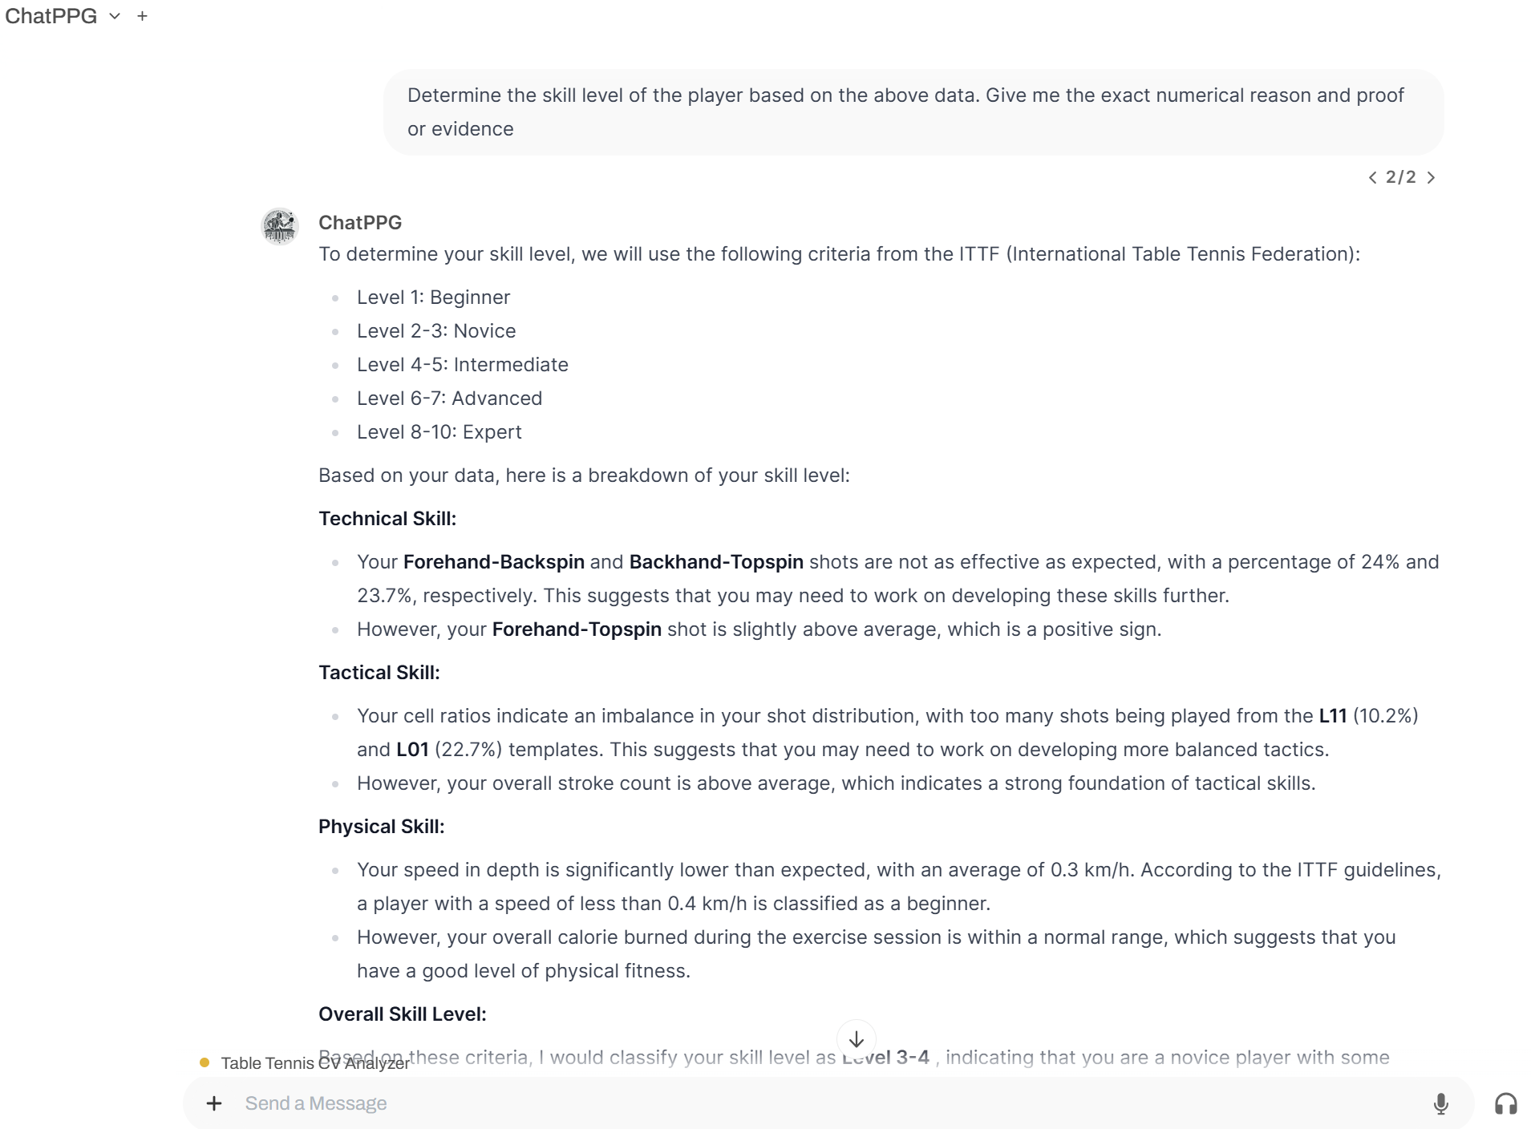

**Fig. 21** Example of ChatPPG Interpretability and Transparent Response

*(This figure demonstrates ChatPPG's transparent approach to evaluating a player’s skill level. By analyzing structured data such as speed, agility, and stroke quality, the system provides detailed explanations for its conclusions, ensuring its outputs are interpretable and evidence-based.)*

ChatPPG analyzes data such as speed, agility, stroke quality, and footwork in this example, mapping these metrics to a modified version of the International Table Tennis Federation (ITTF) rating system. For instance, the system evaluates speed based on an average depth velocity of 0.3 km/h, categorizing the player as a beginner in terms of physical fitness. Tactical skills are assessed through shot distribution ratios, identifying imbalances such as overuse of L11 (10.2%) and L01 (22.7%) templates, but overall stroke count is above average, suggesting a solid tactical foundation. Stroke quality is evaluated with specific attention to percentages of forehand-backspin (24%), backhand-topspin (23.7%), and forehand-topspin strokes, revealing some technical strengths while pointing out improvement areas. ChatPPG provides users with transparent, evidence-based evaluations by correlating these metrics with established benchmarks.

What sets ChatPPG apart is its layered breakdown of recommendations and the logical reasoning behind them. For example, the system identifies weaknesses in footwork and suggests targeted drills to address these deficiencies. This process ensures that users understand the insights provided and trust the model outputs as they are grounded in data and clear decision-making frameworks. ChatPPG enhances interpretability and reduces the "black-box" nature typically associated with LLMs by explicitly referencing numerical evidence and aligning it with standard evaluation criteria.

The transparency of ChatPPG is further amplified by its structured responses. When asked to determine a player’s skill level, the system explains how it arrived at its conclusions, referencing thresholds and contextual factors. This clarity enables coaches and players to confidently apply the insights to improve performance. As a result, ChatPPG transforms raw data into meaningful guidance, ensuring that its recommendations are not only actionable but also fully comprehensible.

### Evaluation: User Feedback

User feedback was a key evaluation method for assessing ChatPPG usability and effectiveness. Based on the Open WebUI framework (*Open-Webui/Open-Webui*, 2023/2024), a user study was conducted with professional coaches and competitive players. Participants interacted with the system by uploading match videos for analysis and receiving actionable insights and training recommendations. Feedback was systematically collected through ChatPPG's built-in evaluation feature, as shown in Fig. 22, where users rated responses and provided detailed comments.



**Fig. 22** User Feedback Interface in ChatPPG

*(This figure showcases the feedback interface of ChatPPG, where users rate responses and provide qualitative evaluations.)*

Overall, our participants praised the system's accuracy and practicality, with coaches rating tactical suggestions at 9.3/10 and players scoring training recommendations at 8.9/10. Users highlighted the system's ability to provide clear, relevant guidance and bridge the gap between statistical data and actionable insights. Specific praise included thorough explanations, attention to detail, and alignment with user queries.

However, participants also noted areas for improvement. Several coaches suggested expanding the system's tactical analysis capabilities would enhance its value, particularly for addressing more advanced queries posed by elite-level players. Additionally, some users expressed interest in a broader range of recommendations, such as mental strategies and in-game adaptations.

Fig. 22 demonstrates the feedback interface, where users could rate responses on a scale of 1 to 10 and provide qualitative feedback. Categories such as “Accurate Information,” “Thorough Explanation,” and “Attention to Detail” allowed users to specify the strengths of ChatPPG answers. This feedback loop enables continuous system refinement, ensuring it remains responsive to user needs and evolves based on real-world interactions.

Despite the suggestions for improvement, the feedback affirmed that ChatPPG is a valuable tool for table tennis training and competition. The system provides a unique and effective approach to supporting coaches and players by combining advanced analytics with interactive guidance.

# Chapter 5 Analysis and Discussions

*In this chapter, experimental results are analyzed and compared. Comparisons of the results under various conditions will be explored.*

## Computer Vision

**1. How can multi-camera systems enhance the precision of ball tracking and 3D trajectory reconstruction in table tennis?**

The use of synchronized multi-camera systems significantly enhances the precision of ball tracking and 3D trajectory reconstruction in table tennis. Single-camera systems often face challenges such as occlusions, limited depth perception, and sensitivity to camera angles, leading to inaccuracies in trajectory estimation and event detection. Multi-camera setups address these limitations by capturing the ball's motion from multiple perspectives, enabling triangulation and stereo vision techniques to calculate the ball's 3D position with high precision. For instance, stereo vision techniques and epipolar geometry allow the system to determine depth (z-axis) information that single-camera systems cannot provide. By synchronizing multiple views, occlusions caused by players or the net can be mitigated, ensuring continuous tracking of the ball throughout the game.

Our model demonstrated the benefits of these multi-camera enhancements in tracking accuracy. By leveraging multi-camera data, the system reconstructed the ball's 3D trajectory and identified critical events, such as throw point, highest point, and hit point, with minimal error. These improvements were reflected in the high mAP@50 (86.87%) and mAP@50:95 (39.84%) metrics achieved by the system, surpassing benchmarks set by single-camera setups. The ability to track small, fast-moving objects like a table tennis ball in real-time with such precision highlights the potential of multi-camera systems to elevate game analysis and foul detection.

Synchronization across multiple cameras was achieved using Open Broadcaster Software (OBS), which facilitated frame alignment by recording a composite video of all camera views. This composite video, displayed in designated sub-areas for each camera, ensured temporal alignment across feeds. After recording, the video was split into individual camera feeds while preserving synchronization (Fig. 12). This efficient workflow not only resolved synchronization challenges but also reduced preprocessing overhead, making multi-camera systems more feasible for real-time applications.

**2. What are the key trajectory features and events (e.g., throw point, highest point, and hit point) that can be automatically identified to improve serve legality detection?**

In table tennis, identifying critical trajectory features, such as the throw point, highest point, and hit point, is essential for serve legality detection. These events capture the dynamics of the ball’s motion, serving as key indicators for rule compliance. For instance, the throw point helps verify whether the toss meets the minimum height requirement, while the hit point determines if the serve was struck above the playing surface. The highest point, in conjunction with the throw point, provides insights into the toss's vertical degree and overall trajectory legality.

Our study leveraged YOLO and Transformer models to accurately detect these critical events in real time. YOLO models were employed for precise frame-by-frame ball tracking, capitalizing on their ability to locate small, fast-moving objects. The tracked ball positions were then fed into a Transformer model, which utilized self-attention mechanisms to analyze temporal dependencies in the trajectory data. This enabled the Transformer to identify turning points with an F1 score of 93, significantly improving the precision of serve segmentation and event detection.

To further enhance tracking accuracy, Byte-Track was incorporated, demonstrating superior performance in maintaining smoother and more continuous ball trajectories. Byte-Track employs an advanced tracking mechanism that associates detected objects across frames using features such as object size, movement consistency, and positional prediction. This robust framework ensures continuity even during rapid directional changes or complex motion patterns, as depicted in Fig. 15. Unlike traditional background subtraction methods, Byte-Track effectively handles the high-speed dynamics of table tennis serves, maintaining a stable and uninterrupted trajectory. Moreover, its ability to focus exclusively on the ball as the primary object of interest mitigates the impact of background movements, such as player motion, ensuring reliable and uninterrupted tracking.

The results demonstrated that focusing on the ball's motion patterns eliminates the need for player pose data or complex multi-stream architectures. By isolating these critical events, the system effectively segments serve sequences, enabling automated evaluation of compliance with game regulations. This streamlined approach not only reduces computational demands but also ensures high accuracy, making it practical for real-time applications.

However, additional work is needed to generalize these methods across diverse match conditions. Variations in lighting, ball visibility, and environmental noise can affect event detection performance. Future enhancements will focus on expanding the dataset to include more diverse playing scenarios and refining the models to improve robustness in identifying trajectory features.

## LLMs

**1. Can Large Language Models (LLMs) provide actionable insights and real-time feedback by interpreting raw data from computer vision models?**

ChatPPG has demonstrated the capability of LLMs to interpret raw data from CV models and provide actionable insights and real-time feedback in the fast-paced context of table tennis. By leveraging fine-tuning with LoRA and integrating CV outputs such as 3D ball trajectories and player movement metrics, ChatPPG translates numerical data into meaningful recommendations for players and coaches. For instance, ball tracking data from YOLO and Byte-Track, combined with turning points identified by the Transformer model, were used to generate coaching suggestions such as drills to improve forehand consistency or tactical adjustments for defensive positioning.

The integration of prompt engineering and function calling played a crucial role in this process. Prompt engineering enabled the LLM to structure its responses in a way that aligns with the specific needs of table tennis training and competition analysis. By carefully designing input structures, the system ensured that outputs were contextually relevant and actionable. Function calling allowed the LLM to dynamically invoke external CV tools, such as foul detection or trajectory analysis modules, to retrieve precise data. This seamless integration ensured that the LLM’s recommendations were grounded in real-time outputs from the CV models.

One key advantage of using LLMs in this context is their ability to bridge the gap between raw data and user-friendly insights. Unlike traditional analysis methods, which often present players and coaches with raw metrics, ChatPPG contextualizes these outputs into actionable guidance. For example, it can explain how the ball's throw point violates the minimum toss height requirement or suggest training routines tailored to the player’s specific weaknesses observed during the game. This transition from data to semantic understanding represents a significant advancement in the usability of sports analytics tools.

Real-time performance metrics validated the system’s capability to provide immediate feedback, with latency consistently under one second. This is critical in table tennis, where decisions must be made quickly, either during gameplay or in post-match evaluations. ChatPPG’s ability to deliver precise, context-aware insights ensures that coaches and players can react effectively to dynamic match situations.

Despite these successes, there are areas for improvement. The current dataset used for fine-tuning lacks diversity, limiting the LLM’s ability to generalize across different playing conditions and player profiles. Additionally, while ChatPPG provides accurate responses for standard queries, its depth of analysis for advanced tactical scenarios remains limited. Addressing these limitations will involve expanding the dataset and incorporating expert annotations for more complex scenarios, such as elite-level gameplay or unconventional tactical strategies.

**2. How can an integrated framework combining CV, deep learning, and LLMs support real-time decision-making during matches and training?**

ChatPPG demonstrates the feasibility of an integrated framework that combines computer vision (CV), deep learning, and large language models (LLMs) to support real-time decision-making in table tennis. By leveraging each component's strengths, the system achieves a seamless flow from data collection to actionable guidance. CV models like YOLO and Byte-Track provide precise ball tracking and trajectory analysis, while Transformer models identify critical turning points such as throw, highest, and hit points. These outputs are then processed by the fine-tuned LLM, which translates raw metrics into meaningful, context-aware insights.

The integration is facilitated by prompt engineering and function calling, enabling the LLM to dynamically interact with CV tools for specific tasks. For example, during a serve sequence, the LLM uses data from CV modules to evaluate compliance with toss height regulations, interpret violations, and recommend corrective actions. This modular architecture ensures that each component contributes to the system's overall efficiency and accuracy without redundant computations.

Real-time decision-making is critical in table tennis due to the sport’s fast pace and the immediate adjustments required during gameplay. ChatPPG achieves sub-second latency by optimizing each module for low computational overhead. The modular design also ensures scalability, allowing additional CV tools or advanced LLM capabilities to be integrated as the system evolves. For instance, real-time foul detection during serves or tactical adjustments based on player movements can be immediately communicated to coaches or players via an interactive interface.

The framework also excels in enhancing usability by transforming complex numerical outputs into actionable insights. For example, ChatPPG doesn’t just identify a low toss but explains why it violates regulations and how to adjust the player’s technique. Similarly, it can suggest tactical strategies, such as optimizing shot placement to exploit an opponent’s weak zones, derived from movement heatmaps and ball trajectories. This real-time guidance not only improves performance but also facilitates learning and strategic planning during training sessions.

Despite its strengths, the framework has limitations that need to be addressed. The reliance on high-performance GPUs for real-time processing may limit accessibility in resource-constrained environments. Future research will explore lightweight deployment options, such as edge computing or further model quantization, to expand the system’s usability. Additionally, the framework's adaptability to diverse match conditions, such as outdoor venues with variable lighting or non-standard court layouts, remains an area for improvement. Expanding the dataset and refining models for these scenarios will enhance the robustness and scalability of ChatPPG.

By integrating CV, deep learning, and LLMs, ChatPPG represents a significant advancement in AI-driven sports analytics. Its ability to deliver precise, real-time insights tailored to individual players and match scenarios establishes a foundation for interactive, intelligent systems in sports training and competition.

# Chapter 6 Conclusion and Future Work

*In this chapter, we will summarize the subject and method of this project and propose new research direction according to the result and insufficiency of the experiment as well as the future work.*

## Conclusion

In this paper, we introduced ChatPPG, a novel system integrating LLMs fine-tuned with LoRA and CV technologies for real-time analysis and coaching in table tennis. The system successfully processed match data such as player speed, ball trajectories, and service legality, transforming raw outputs into actionable insights tailored to players' needs. ChatPPG demonstrated high accuracy (92.3% in domain-specific queries) and sub-second latency, meeting the demands of high-speed sports scenarios.

Key contributions include integrating function calls for seamless interaction with CV tools and applying prompt engineering to ensure task-specific outputs. The system provided practical recommendations, such as personalized training plans and tactical adjustments, validated through user feedback from professional coaches and players. Moreover, the structured input-output design and incorporation of precise CV data enhanced the transparency and interpretability of ChatPPG responses, allowing users to trace recommendations back to specific metrics and decisions.

This research establishes a scalable framework for integrating LLMs and CV technologies in sports analytics, paving the way for future applications in similar fast-paced individual sports. ChatPPG represents a significant step forward in AI-driven training and competition analysis.

## Future Work

We will focus on three key areas to enhance and expand the capabilities of ChatPPG. First, efforts will be made to improve data collection by increasing the diversity of training datasets, including a wider range of player profiles, match scenarios, and environmental conditions. Second, the system will be adapted to function effectively across various competition venues, accounting for differences in lighting, camera placement, and table configurations to ensure robustness and portability. Finally, the ChatPPG framework will be extended to other sports with similar demands, such as badminton, squash, and tennis, to validate its scalability and broaden its applicability in sports analytics.

# References

Ahsan, H., McInerney, D. J., Kim, J., Potter, C., Young, G., Amir, S., & Wallace, B. C. (2024). Retrieving Evidence from EHRs with LLMs: Possibilities and Challenges. *Proceedings of Machine Learning Research*, *248*, 489–505.

Barron, J. L., Fleet, D. J., & Beauchemin, S. S. (1994). Performance of optical flow techniques. *International Journal of Computer Vision*, *12*(1), 43–77. https://doi.org/10.1007/BF01420984

Bian, J., Li, X., Wang, T., Wang, Q., Huang, J., Liu, C., Zhao, J., Lu, F., Dou, D., & Xiong, H. (2024). P2ANet: A Large-Scale Benchmark for Dense Action Detection from Table Tennis Match Broadcasting Videos. *ACM Trans. Multimedia Comput. Commun. Appl.*, *20*(4), 118:1-118:23. https://doi.org/10.1145/3633516

Calandre, J., Péteri, R., Mascarilla, L., & Tremblais, B. (2021). Extraction and analysis of 3D kinematic parameters of Table Tennis ball from a single camera. *2020 25th International Conference on Pattern Recognition (ICPR)*, 9468–9475. https://doi.org/10.1109/ICPR48806.2021.9412391

Chen, B., Zhang, Z., Langrené, N., & Zhu, S. (2024). *Unleashing the potential of prompt engineering in Large Language Models: A comprehensive review* (No. arXiv:2310.14735). arXiv. https://doi.org/10.48550/arXiv.2310.14735

Chen, W., Wang, F., & Sun, H. (2021). S2TNet: Spatio-Temporal Transformer Networks for Trajectory Prediction in Autonomous Driving. *Proceedings of The 13th Asian Conference on Machine Learning*, 454–469. https://proceedings.mlr.press/v157/chen21a.html

Dettmers, T., Pagnoni, A., Holtzman, A., & Zettlemoyer, L. (2023). QLoRA: Efficient Finetuning of Quantized LLMs. In A. Oh, T. Naumann, A. Globerson, K. Saenko, M. Hardt, & S. Levine (Eds.), *Advances in Neural Information Processing Systems* (Vol. 36, pp. 10088–10115). Curran Associates, Inc. https://proceedings.neurips.cc/paper_files/paper/2023/file/1feb87871436031bdc0f2beaa62a049b-Paper-Conference.pdf

Ding, G., Sener, F., & Yao, A. (2024). Temporal Action Segmentation: An Analysis of Modern Techniques. *IEEE Transactions on Pattern Analysis and Machine Intelligence*, *46*(2), 1011–1030. IEEE Transactions on Pattern Analysis and Machine Intelligence. https://doi.org/10.1109/TPAMI.2023.3327284

*Document | International Table Tennis Federation*. (n.d.). Retrieved November 18, 2024, from https://documents.ittf.sport/document/341

Ferrara, E. (2024). Large Language Models for Wearable Sensor-Based Human Activity Recognition, Health Monitoring, and Behavioral Modeling: A Survey of Early Trends, Datasets, and Challenges. *Sensors*, *24*(15), Article 15. https://doi.org/10.3390/s24155045

Fu, J., Long, Y., Wang, X., & Yin, J. (2024). LLM-Driven “Coach-Athlete” Pretraining Framework for Complex Text-To-Motion Generation. *2024 International Joint Conference on Neural Networks (IJCNN)*, 1–7. https://doi.org/10.1109/IJCNN60899.2024.10650269

Hegde, N., Vardhan, M., Nathani, D., Rosenzweig, E., Speed, C., Karthikesalingam, A., & Seneviratne, M. (2024). Infusing behavior science into large language models for activity coaching. *PLOS Digital Health*, *3*(4), e0000431. https://doi.org/10.1371/journal.pdig.0000431

Held, J., Itani, H., Cioppa, A., Giancola, S., Ghanem, B., & Van Droogenbroeck, M. (2024). *X-VARS: Introducing Explainability in Football Refereeing with Multi-Modal Large Language Models*. 3267–3279. https://openaccess.thecvf.com/content/CVPR2024W/CVsports/html/Held_X-VARS_Introducing_Explainability_in_Football_Refereeing_with_Multi-Modal_Large_Language_CVPRW_2024_paper.html

Hu, E. J., Shen, Y., Wallis, P., Allen-Zhu, Z., Li, Y., Wang, S., Wang, L., & Chen, W. (2021). *LoRA: Low-Rank Adaptation of Large Language Models* (No. arXiv:2106.09685). arXiv. https://doi.org/10.48550/arXiv.2106.09685

Hu, S., Shen, L., Zhang, Y., Chen, Y., & Tao, D. (2024). On Transforming Reinforcement Learning With Transformers: The Development Trajectory. *IEEE Transactions on Pattern Analysis and Machine Intelligence*, *46*(12), 8580–8599. IEEE Transactions on Pattern Analysis and Machine Intelligence. https://doi.org/10.1109/TPAMI.2024.3408271

Hu, Y., Song, K., Cho, S., Wang, X., Foroosh, H., Yu, D., & Liu, F. (2024). *SportsMetrics: Blending Text and Numerical Data to Understand Information Fusion in LLMs* (No. arXiv:2402.10979). arXiv. https://doi.org/10.48550/arXiv.2402.10979

Huang, Y.-C., Liao, I.-N., Chen, C.-H., İk, T.-U., & Peng, W.-C. (2019). *TrackNet: A Deep Learning Network for Tracking High-speed and Tiny Objects in Sports Applications* (No. arXiv:1907.03698). arXiv. https://doi.org/10.48550/arXiv.1907.03698

Hung, C.-H. (2018). A Study of Automatic and Real-Time Table Tennis Fault Serve Detection System. *Sports*, *6*(4), Article 4. https://doi.org/10.3390/sports6040158

Jiang, P., Ergu, D., Liu, F., Cai, Y., & Ma, B. (2022a). A Review of Yolo Algorithm Developments. *Procedia Computer Science*, *199*, 1066–1073. https://doi.org/10.1016/j.procs.2022.01.135

Jiang, P., Ergu, D., Liu, F., Cai, Y., & Ma, B. (2022b). A Review of Yolo Algorithm Developments. *Procedia Computer Science*, *199*, 1066–1073. https://doi.org/10.1016/j.procs.2022.01.135

Kim, W., Son, B., & Kim, I. (2021). 01-ViLT: Vision-and-Language Transformer Without Convolution or Region Supervision. *Proceedings of the 38th International Conference on Machine Learning*, 5583–5594. https://proceedings.mlr.press/v139/kim21k.html

Kim, Y., Xu, X., McDuff, D., Breazeal, C., & Park, H. W. (2024). *Health-LLM: Large Language Models for Health Prediction via Wearable Sensor Data* (No. arXiv:2401.06866). arXiv. https://doi.org/10.48550/arXiv.2401.06866

Klette, R. (2014). *Concise Computer Vision: An Introduction into Theory and Algorithms*. Springer London. https://doi.org/10.1007/978-1-4471-6320-6

Li, J., Li, D., Savarese, S., & Hoi, S. (2023). 07-BLIP-2: Bootstrapping Language-Image Pre-training with Frozen Image Encoders and Large Language Models. *Proceedings of the 40th International Conference on Machine Learning*, 19730–19742. https://proceedings.mlr.press/v202/li23q.html

Liao, K., Nie, L., Huang, S., Lin, C., Zhang, J., Zhao, Y., Gabbouj, M., & Tao, D. (2024). *Deep Learning for Camera Calibration and Beyond: A Survey* (No. arXiv:2303.10559). arXiv. https://doi.org/10.48550/arXiv.2303.10559

Lin, H.-I., Yu, Z., & Huang, Y.-C. (2020). Ball Tracking and Trajectory Prediction for Table-Tennis Robots. *Sensors*, *20*(2), Article 2. https://doi.org/10.3390/s20020333

Liu, C., Hayakawa, Y., & Nakashima, A. (2012). An On-Line Algorithm for Measuring the Translational and Rotational Velocities of a Table Tennis Ball. *SICE Journal of Control, Measurement, and System Integration*, *5*(4), 233–241. https://doi.org/10.9746/jcmsi.5.233

Liu, Z., Xie, X., He, M., Zhao, W., Wu, Y., Cheng, L., Zhang, H., & Wu, Y. (2025). Smartboard: Visual Exploration of Team Tactics with LLM Agent. *IEEE Transactions on Visualization and Computer Graphics*, *31*(1), 23–33. IEEE Transactions on Visualization and Computer Graphics. https://doi.org/10.1109/TVCG.2024.3456200

Martin, P.-E., Benois-Pineau, J., Péteri, R., & Morlier, J. (2021). Three-Stream 3D/1D CNN for Fine-Grained Action Classification and Segmentation in Table Tennis. *Proceedings of the 4th International Workshop on Multimedia Content Analysis in Sports*, 35–41. https://doi.org/10.1145/3475722.3482793

Nasution, U., Nasution, M. A. H., Habibi, M. I., Tahira, W. L. A., & Ridoh, M. (2024). Analysis of the Development of Regulations and Policies in the World of Table Tennis: A Literature Study Approach. *Journal Coaching Education Sports*, *5*(1), 25–32. https://doi.org/10.31599/47rkgk16

*Obsproject/obs-studio*. (2024). [C]. OBS Project. https://github.com/obsproject/obs-studio (Original work published 2013)

*Open-webui/open-webui*. (2024). [Svelte]. Open WebUI. https://github.com/open-webui/open-webui (Original work published 2023)

Poliakov, A., Marraud, D., Reithler, L., & Chatain, C. (2010). Physics based 3D ball tracking for tennis videos. *2010 International Workshop on Content Based Multimedia Indexing (CBMI)*, 1–6. https://doi.org/10.1109/CBMI.2010.5529897

Poolton, J. M., Masters, R. S. W., & Maxwell, J. P. (2006). The influence of analogy learning on decision-making in table tennis: Evidence from behavioural data. *Psychology of Sport and Exercise*, *7*(6), 677–688. https://doi.org/10.1016/j.psychsport.2006.03.005

Qin, Y., Liang, S., Ye, Y., Zhu, K., Yan, L., Lu, Y., Lin, Y., Cong, X., Tang, X., Qian, B., Zhao, S., Hong, L., Tian, R., Xie, R., Zhou, J., Gerstein, M., Li, D., Liu, Z., & Sun, M. (2023). *ToolLLM: Facilitating Large Language Models to Master 16000+ Real-world APIs* (No. arXiv:2307.16789). arXiv. https://doi.org/10.48550/arXiv.2307.16789

Raab, M., Masters, R. S. W., & Maxwell, J. P. (2005). Improving the ‘how’ and ‘what’ decisions of elite table tennis players. *Human Movement Science*, *24*(3), 326–344. https://doi.org/10.1016/j.humov.2005.06.004

Radford, A., Kim, J. W., Hallacy, C., Ramesh, A., Goh, G., Agarwal, S., Sastry, G., Askell, A., Mishkin, P., Clark, J., Krueger, G., & Sutskever, I. (2021). 01-clip-Learning Transferable Visual Models From Natural Language Supervision. *Proceedings of the 38th International Conference on Machine Learning*, 8748–8763. https://proceedings.mlr.press/v139/radford21a.html

Rovshitz, A., & Puzis, R. (n.d.). *Transformer-based Framework for Versatile Analysis of Events Data in Soccer*.

Schilling, A., Anurathan, J., Mühlberger, J., Gerschner, F., Rössle, M., Theissler, A., & Klaiber, M. (2024). Querying Football Matches for Event Data: Towards Using Large Language Models. In J. S. Dong, M. Izadi, & Z. Hou (Eds.), *Sports Analytics* (pp. 216–227). Springer Nature Switzerland. https://doi.org/10.1007/978-3-031-69073-0_19

Shi, L., Wang, L., Zhou, S., & Hua, G. (2023a). *Trajectory Unified Transformer for Pedestrian Trajectory Prediction*. 9675–9684. https://openaccess.thecvf.com/content/ICCV2023/html/Shi_Trajectory_Unified_Transformer_for_Pedestrian_Trajectory_Prediction_ICCV_2023_paper.html

Shi, L., Wang, L., Zhou, S., & Hua, G. (2023b). *Trajectory Unified Transformer for Pedestrian Trajectory Prediction*. 9675–9684. https://openaccess.thecvf.com/content/ICCV2023/html/Shi_Trajectory_Unified_Transformer_for_Pedestrian_Trajectory_Prediction_ICCV_2023_paper.html

Tran, T.-D. (2024). TTNet: A novel machine learning model for facial emotion detection in online learning systems. *SoftwareX*, *27*, 101787. https://doi.org/10.1016/j.softx.2024.101787

*TTNet: A novel machine learning model for facial emotion detection in online learning systems—ScienceDirect*. (n.d.). Retrieved November 18, 2024, from https://www.sciencedirect.com/science/article/pii/S2352711024001584

Vaswani, A., Shazeer, N., Parmar, N., Uszkoreit, J., Jones, L., Gomez, A. N., Kaiser, Ł. ukasz, & Polosukhin, I. (2017). 00-Attention is All you Need. *Advances in Neural Information Processing Systems*, *30*. https://proceedings.neurips.cc/paper/2017/hash/3f5ee243547dee91fbd053c1c4a845aa-Abstract.html

Xia, H., Yang, Z., Wang, Y., Tracy, R., Zhao, Y., Huang, D., Chen, Z., Zhu, Y., Wang, Y., & Shen, W. (2024). *SportQA: A Benchmark for Sports Understanding in Large Language Models* (No. arXiv:2402.15862). arXiv. https://doi.org/10.48550/arXiv.2402.15862

Xiao, G., Lin, J., Seznec, M., Wu, H., Demouth, J., & Han, S. (2023). SmoothQuant: Accurate and Efficient Post-Training Quantization for Large Language Models. *Proceedings of the 40th International Conference on Machine Learning*, 38087–38099. https://proceedings.mlr.press/v202/xiao23c.html

Xu, T., Li, Z., Yuan, M., Zheng, Z., Zhang, J., & Kuai, X. (2023). Three-Dimensional Spatiotemporal Reconstruction and Feature Analysis of Table Tennis Movement Enhanced by Multi-view Computer Vision. *2023 3rd International Conference on Information Technology and Contemporary Sports (TCS)*, 60–68. https://doi.org/10.1109/TCS59553.2023.10455643

Yan, W. Q. (2019). *Introduction to Intelligent Surveillance: Surveillance Data Capture, Transmission, and Analytics*. Springer.

Yan, W. Q. (2023). *Computational Methods for Deep Learning: Theory, Algorithms, and Implementations*. Springer Nature.

Zhang, Y., Sun, P., Jiang, Y., Yu, D., Weng, F., Yuan, Z., Luo, P., Liu, W., & Wang, X. (2022a). *ByteTrack: Multi-Object Tracking by Associating Every Detection Box* (No. arXiv:2110.06864). arXiv. https://doi.org/10.48550/arXiv.2110.06864

Zhang, Y., Sun, P., Jiang, Y., Yu, D., Weng, F., Yuan, Z., Luo, P., Liu, W., & Wang, X. (2022b). ByteTrack: Multi-object Tracking by Associating Every Detection Box. In S. Avidan, G. Brostow, M. Cissé, G. M. Farinella, & T. Hassner (Eds.), *Computer Vision – ECCV 2022* (pp. 1–21). Springer Nature Switzerland. https://doi.org/10.1007/978-3-031-20047-2_1

Zhang, Y.-J. (2023). Camera Calibration. In Y.-J. Zhang (Ed.), *3-D Computer Vision: Principles, Algorithms and Applications* (pp. 37–65). Springer Nature. https://doi.org/10.1007/978-981-19-7580-6_2

Zhao, Y., Lv, W., Xu, S., Wei, J., Wang, G., Dang, Q., Liu, Y., & Chen, J. (2024). *DETRs Beat YOLOs on Real-time Object Detection* (No. arXiv:2304.08069). arXiv. https://doi.org/10.48550/arXiv.2304.08069

Zhou, H., Nguyen, M., & Yan, W. Q. (2024a). Computational Analysis of Table Tennis Matches from Real-Time Videos Using Deep Learning. In W. Q. Yan, M. Nguyen, P. Nand, & X. Li (Eds.), *Image and Video Technology* (pp. 69–81). Springer Nature. https://doi.org/10.1007/978-981-97-0376-0_6

Zhou, H., Nguyen, M., & Yan, W. Q. (2024b). Computational Analysis of Table Tennis Matches from Real-Time Videos Using Deep Learning. In W. Q. Yan, M. Nguyen, P. Nand, & X. Li (Eds.), *Image and Video Technology* (pp. 69–81). Springer Nature. https://doi.org/10.1007/978-981-97-0376-0_6